HV Rack Wiring Proposal

Each sextant has 195 tubes and 94 HV cables according to this map

Layer | # of modules | 2x8 | 3x8 | 2x7 | # of tubes  (# of HV ch.)
1 | 6 | 2 | 1 | 3 | 13
2 | 6 | 3 | 1 | 2 | 13
3 | 6 | 5 | 1 | - | 13
4 | 7 | 5 | - | 2 | 14
6 | 7 | 3 | 1 | 3 | 15
8 | 8 | 4 | - | 4 | 16
10 | 8 | 8 | - | - | 16
12 | 8 | 6 | 1 | 1 | 17
14 | 9 | 8 | - | 1 | 18
16 | 9 | 8 | 1 | - | 19
17 | 10 | 8 | - | 2 | 20
18 | 10 | 10 | - | - | 20
Total | 94 |  |  |  | 195

Each sextant has 3 HV power supplies each with 80 channels for a total of 240 channels. We try to reserve a 20 channel block in one of the power supplies should we ever have to re-condition tubes (a.k.a. Hospital)

Assuming radial symmetry in the occupancy of the LST detector it is reasonable to assign LST tubes to HV channels layer by layer.
To accommodate potentially high rates in layer 1 we will use 2 HV channels per layer 1 tube.

In the proposed scheme the Hospital is at a central location so it can be reached easily by any HV wire. We also tried to keep those HV blocks that are not completely filled near the center.

Obsolete (see next page)

 | HV Channels  0 – 19 | HV Channels  20 – 39 | HV Channels  40 – 59 | HV Channels  60 – 79
HVPS  1 | Layer 18  20 tubes | Layer 14  18 tubes  2 free | Layer 8  16 tubes  Layer 6  2 tubes  2 free | Layer 4  14 tubes  Layer 6  6 tubes
HVPS  2 | Layer 1  13 (half) tubes  Layer 2  7 tubes | Layer 12  17 tubes  3 free | Hospital  20 free | Layer 1  13 (half) tubes  Layer 2  6 tubes  1 free
HVPS  3 | Layer 17  20 tubes | Layer 16  19 tubes  1 free | Layer 10  16 tubes  4 free | Layer 3  13 tubes  Layer 6  7 tubes

Cable Length: Long enough for every wire to reach the hospital (this corresponds to the distance from HVPS1:channel 0 to HVPS2:
channel 59)

Modified Layout (8/14/2004)
This is more in-line with the installation schedule

 | HV Channels  0 – 19 | HV Channels  20 – 39 | HV Channels  40 – 59 | HV Channels  60 – 79
HVPS  1 | Layer 3  13 tubes  Layer 6  7 tubes | Layer 1  13 (half) tubes  Layer 2  7 tubes | Layer 1  13 (half) tubes  Layer 2  6 tubes  1 free | Layer 4  14 tubes  Layer 6  6 tubes
HVPS  2 | Layer 10  16 tubes  4 free | Layer 12  17 tubes  3 free | Hospital  20 free | Layer 8  16 tubes  Layer 6  2 tubes  2 free
HVPS  3 | Layer 17  20 tubes | Layer 16  19 tubes  1 free | Layer 14  18 tubes  2 free | Layer 18  20 tubes

Cable Length: Long enough for every wire to reach the hospital (this corresponds to the distance from HVPS1:channel 0 to HVPS2:
channel 59)

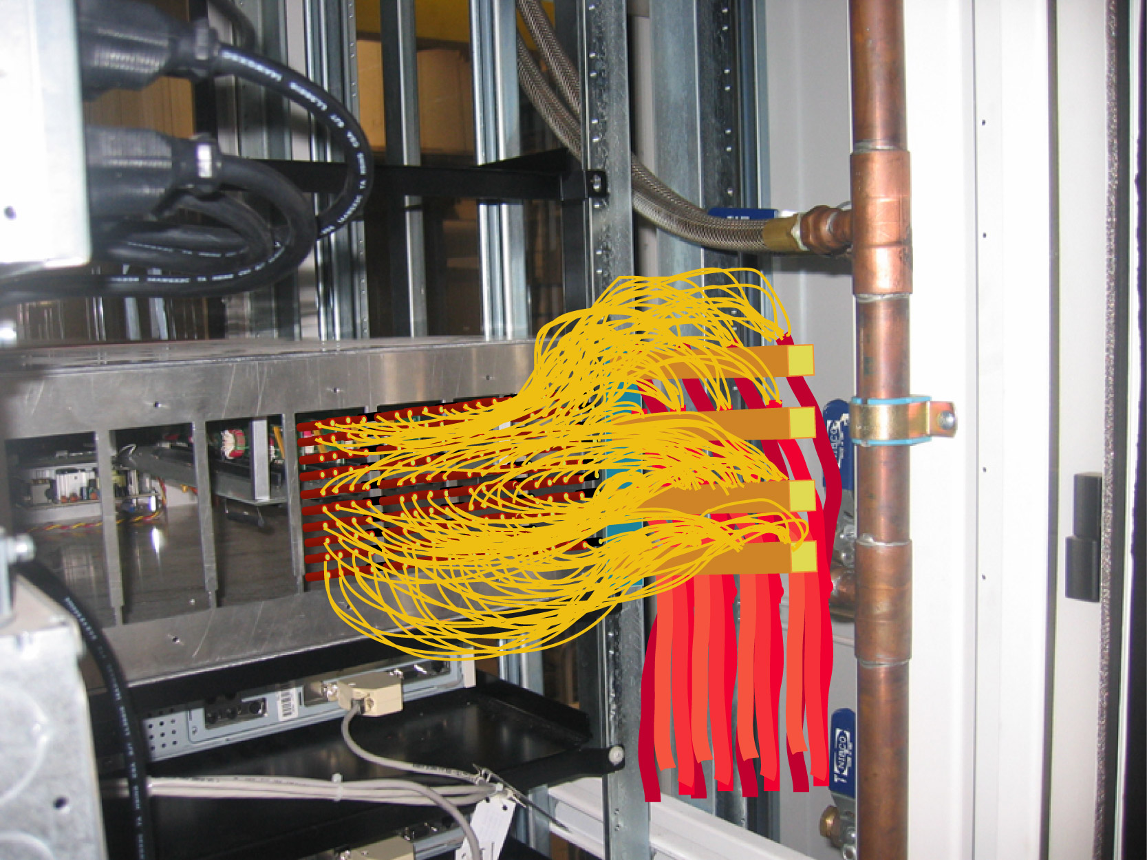
Figure 1 Strain relief for 16 HV cables (1/6 of a sextant)

