High Voltage System.
A multi-channel High Voltage system will be required to operate the LST detector. High voltage values around 5 kV are typical with single tube currents less than 100 nA. In the baseline design each layer of a double layer tube will have its own HV connection. For the large cell solution we consider using multiple HV connections per tube. This will help to reduce detector inefficiencies should parts of a tube develop HV problems. Each HV channel will include a current monitor with a resolution of better than 10 nA and a protection circuit that automatically limits the current and prevents a tube from getting permanently damaged. In addition, the HV system has provide a mechanism to completely disconnect individual tubes.

The HV system will consist of the following building blocks that will be discussed in greater detail in the following sections:
- HV power supply with current monitor and over current protection.
- HV distribution
- HV cables from the electronics house to the detector
- HV connector including HV capacitor

The general requirements for the HV system are summarized in Table 1.

 | Double Layer | Large Cells
Individual HV connections | 4152 | 2000  (assuming 2 HV channels per tube)
HV Channel  (depending on design choices) | 1038-4152 | 1000 - 2000
Worst case rate per tube (2 Hz/cm²) | 6400 Hz | 6.4 – 13 kHz
Max. tube current | 640 nA  (per layer) | 640 – 1300 nA
Typical rate per tube (0.2 Hz/cm²) | 640 Hz | 0.6 – 1.3 kHz
Typical tube current | 60 nA  (per layer) | 60 – 130 nA
Table 1 HV Requirements

Over-Current Protection
(More info at http://www.physics.ohio-state.edu/~klaus/LST/HV/ZeusHV.pdf)
Limited streamer tubes, especially during the very first part of their life, have a certain probability of having self-sustained discharges resulting in a large current flow. It was shown that leaving an LST in such a condition results in permanent damage. To prevent this problem, limited streamer tubes are usually conditioned over extended periods before being installed in the detector. Nevertheless, discharges will still happen from time to time. To protect the LST under these circumstances we adopted a passive circuit that was developed by the University of Padova for the ZEUS LST detector. The circuit diagram is shown in Figure 1 and its current limiting abilities are demonstrated in Figure 2.
Figure 1 Over-Current Protection Circuit (ZEUS)

Figure 2 High voltage as function of chamber current.

We tested the circuit at Ohio State and decided to use it for the BaBar LST detector.

HV cables
(More info at http://www.physics.ohio-state.edu/~klaus/LST/HV/HVcable.pdf)
We will use a multi-conductor HV cable made by Kerpen-Kabel. A picture of the cable is shown in Figure 3. The outer jacket is halogen free and flame retardant. It comes in 25 wires or 37 wires configurations (other available on request) and is rated for 6 KV (wire to wire). Factory tests are performed at 12 KV. We have obtained a 25 m long sample of this cable which will allow us to perform our own measurements and to setup a complete HV test stand with cable lengths comparable to those we will encounter in IR-II.
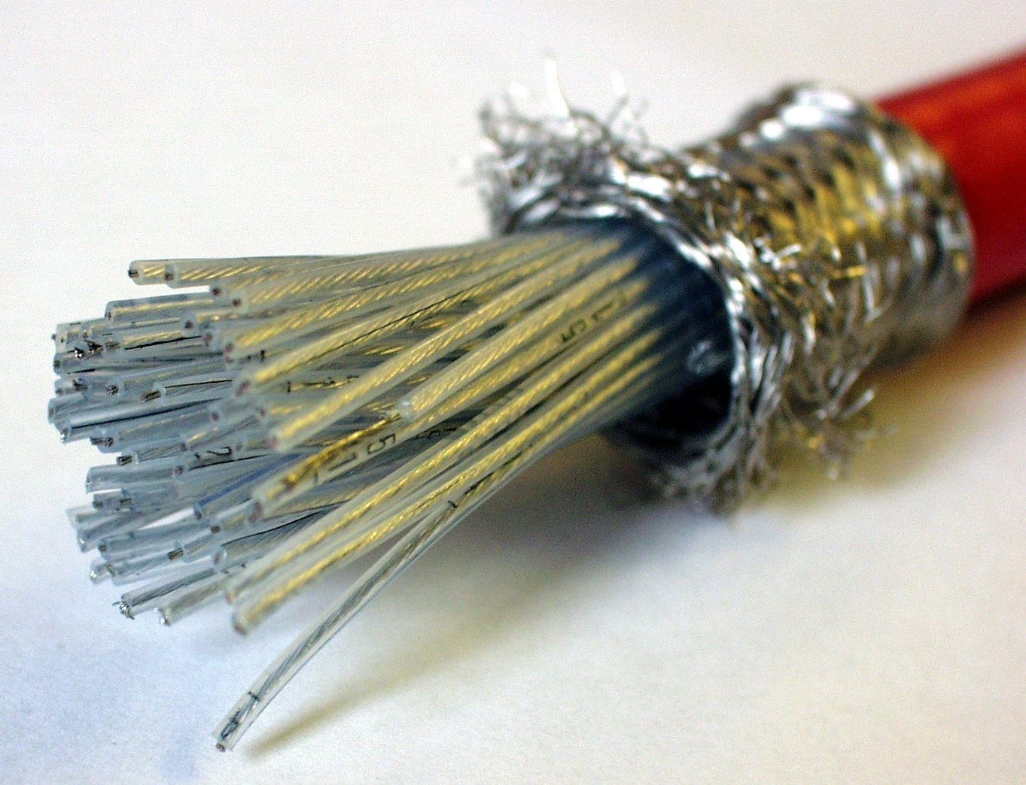
Figure 3 Multi-wire HV cable

HV Connector, HV Capacitor
(see also http://www.physics.ohio-state.edu/~klaus/LST/signal/signalpath.pdf and http://www.slac.stanford.edu/~changguo/BaBar_PST/Stripsignalpath.ppt)

The current baseline solution did not include a direct capacitive coupling between anodes and cathodes. This differs from other LST detector design. SLD, for example, used a 2 nF capacitor between ground and HV mounted on a separate HV board close (< 1 m) to the detector. A schematic drawing of the SLD strip read-out is shown in Figure 4 (from NIM A290 353-369). We studied the effect of the HV capacitor on the signals picked up by the strips and concluded that a 500 pF – 1000 pF capacitor has to be used. The exact value will be determined experimentally once the final design choices have been made and the prototypes become available.
The 155 Ω resistor was included by SLD to reduce cross talk between channels. Its value was determined experimentally. Again, we will study this with our LST prototypes.
Inserted in the end-caps of each tube are two 2 mm banana plugs and one 2 mm jack for high voltage and ground connections. In the double layer design the ground connection is shared by both layers. Work has started to design an integrated HV connector that besides the HV and ground jacks and plugs includes the HV capacitors and eventually the 155 Ω resistor, should we decide to follow the SLD design.

Figure 4 SLD streamer tube read-out

HV Power Supply and Distribution
The high voltage power supplies for the LST detector have to provide regulated HV up to 5 KV, current monitoring and over-current protection.

CAEN SY546 HV Supply
(see http://www-physics.mps.ohio-state.edu/~klaus/LST/HV/sy546_rev0.pdf )
These requirements are satisfied by a commercial system available from CAEN that represents our baseline option. This system, the SY546 developed for the LVD experiment at the "Gran Sasso" laboratory, consists of 4u high crates hosting 8 HV boards. Each board has one HV regulated power supply that feeds 12 output channels. All outputs are set to the same voltage but the current of each channel is individually monitored and alarm thresholds can be set for each of them. The electrical characteristics of the SY 546 system are summarized in the following table:

max. output voltage | max. output current | monitoring resolution
6 kV | 5-10 µA | 5 nA

The SY546 is equipped with a CAENet controller and similar CAEN power supplies are already in use in BaBar. Hence we expect the integration with the BaBar detector control system to be straightforward. The SY546 system is no longer in the CAEN catalogue but the Padova group has learnt from CAEN that they are willing (and able) to produce this system for BaBar should we decide to go this route. Initial cost estimates are at $160,000 for 1000 HV channels. Furthermore, we are investigating if some of the SY546 systems no longer needed by the LVD experiment could be made available to BaBar. These discussions are still ongoing. We have also learnt that an opto-coupler component in the SY546 modules is failing. The Padova group is discussing with CAEN how (and at what cost) this problem can be fixed. A 96 channel SY546 system is now available at Ohio State. Another SY546 crate will be set up at Pol. Hi. Tech to support on-site quality control tests.
In the small cell, double layer solution we will need up to 4152 HV channels. It is unlikely that we receive that many channels from LVD and hence we will have to gang together 2 or 4 tubes. Since we want to maintain the ability to disconnect individual tubes from high voltage we have to add a (HV) distribution panel near the HV power supplies. Work on the distribution system has not yet started.

The SY546 power supply has a built in trip mechanism that shuts off an output channel should the current rise above a preset threshold. However, it does not include the over-current protection circuit discussed above. We are investigating if and how this circuit can be added to the SY546 HV boards.

Custom Designed HV System
(see also http://www-physics.mps.ohio-state.edu/~klaus/LST/HV/HV.htm )
While the SY546 system provides an adequate HV solution for the LST detector there are still enough questions (availability, repair of failing components, how to integrate the over-current protection circuit) that we began to develop custom HV power supplies. We came up with a design that is quite similar to the SY-546 system with a number of output channels sharing a common high voltage setting. Here are a few of the relevant features
- Self-contained unit ("Pizza Box") with 36 - 50 channels
- Outputs are protected against discharge (ZEUS design)
- Integrated controller for ramping, current monitor, HV setting etc.
- Individual current measurement for each channel
- Fast Ethernet Interface to control system
A schematic diagram of this design is shown in Figure 5. Several high voltage transistors are configured as a HV Op-Amp that provides an adjustable output voltage for 25 or more channels. As in the SY546 system the output channels are set to the same voltage but current monitoring and over-current protection are done on a channel by channel basis. As is indicated in Figure 5 the current limiting circuit from ZEUS is integrated in this design. Not shown in Figure 5 is the digital part which includes an Xilinx FPGA and a micro-controller with an integrated FastEthernet interface. A first prototype with 5 channels (Figure 6) has been built and was successfully tested (linearity of current monitor, output protection, noise and ripple). The current monitor circuit is based on a VCO chip (voltage to frequency convert) and offers fast response time on the order of a few micro-seconds. The CAEN HV supply is significantly slower. For normal operation this is not relevant but some of our quality control tests such as the scan with a radioactive source require high speed current monitoring. A decision on the HV system will made in a few months when it becomes clearer how many SY546 crates will be available from the LVD experiment.
Figure 5 HV power supply block diagram

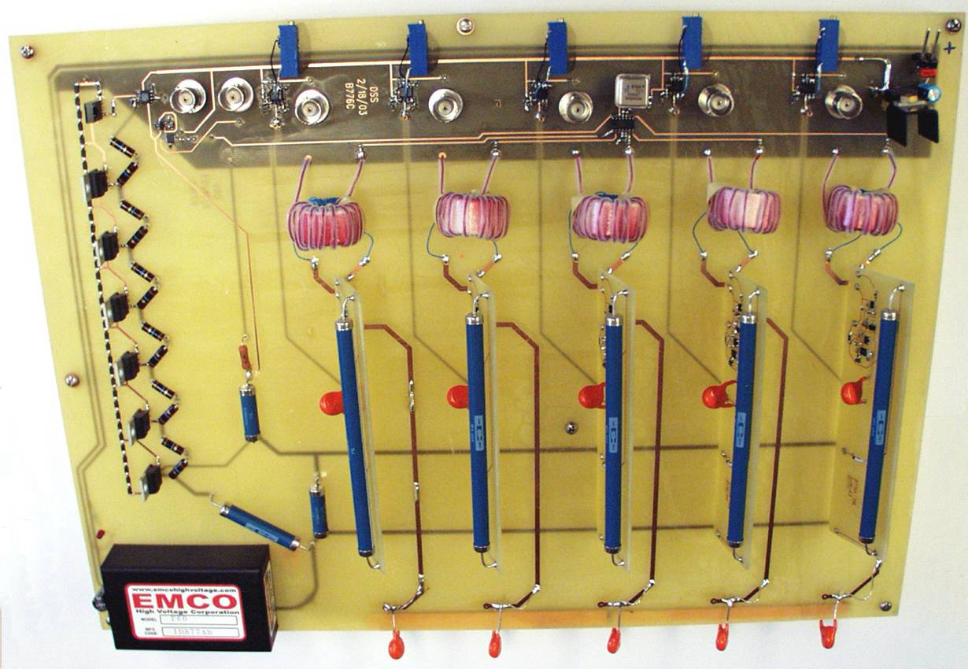
Figure 6 5 ch. prototype HV supply

