BaBar LST High Voltage Power Supply

GUI User’s Instructions
Draft version 1.0

March 25th 2004

This document is meant as a quick reference to enable LST collaborators to use the OSU HV power supply test graphical user interface.

It is based on the preliminary version of the software available on the OSU LST CVS repository and will be updated together with the software as new features will be added and current features will be perfected.

Access to the OSU-maintained CVS qc repository is assumed (see Appendix, if you still have trouble getting the most current software contact someone at OSU), so the document is based on the latest version of the software at the date of print.

For installation and setup instruction consult the Users Manual.

Getting Started
The monitoring Graphical User Interface runs on Linux (it has been developed using Qt on Red Hat 9). If you are running on Windows or MacOS you simply need to run an X server program (Exceed, Hummingbird, X11 etc) on your machine and connect to a Linux machine on which the GUI will run (as usual you will have to take care of the DISPLAY environment variable and X-host permissions).

You need to get a copy of the HVWin executable. Either by checking out the qc CVS module from OSU and build ing your local executable (see Appendix on CVS) or by copying the executable directly (your Linux system has to have the qt libraries installed but since KDE is based on this framework it’s almost always available). If you have problems you can check the qt website at www.trolltech.com).

You can start the GUI by typing the command:

./HVWin

The main GUI panel will then pop up:

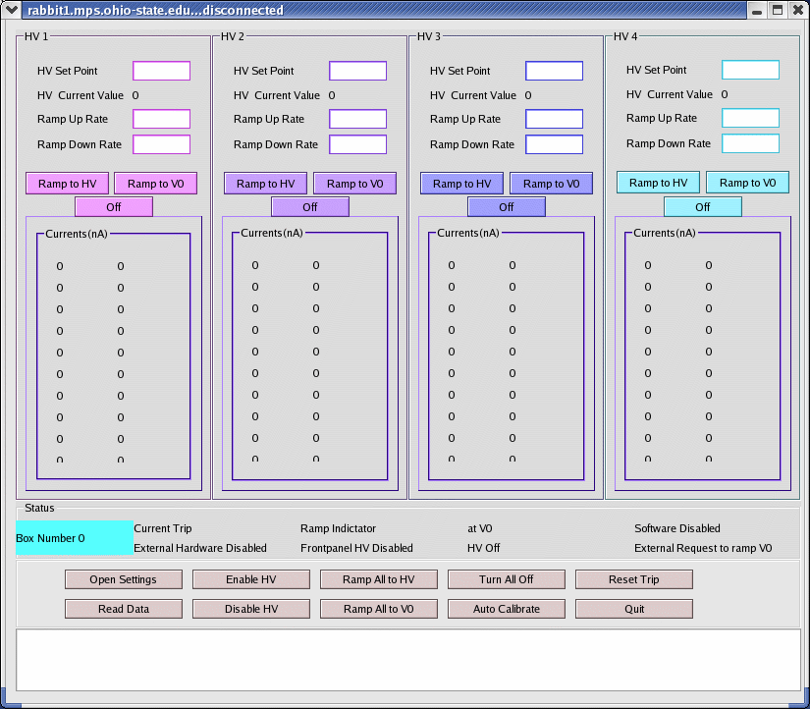
The main GUI panel X-window is named after your HV box IP name (in these examples rabbit5.mps.ohio-state.edu and rabbit2.mps.ohio-state.edu).
The interface top part is divided horizontally into 4 sub-panels, HV1, HV2, HV3, and HV4, one for each HV channel (4 independent HV channels per box can be controlled in voltage, each feeding 20 output channels for a total of 80 output channels per box that are monitored in current).
The Status sub-panel displays status information about the HV box being monitored and, at the bottom of the panel, buttons are provided to control the HV supply.

In order to start click the Open Settings button.
The Settings panel will pop up:

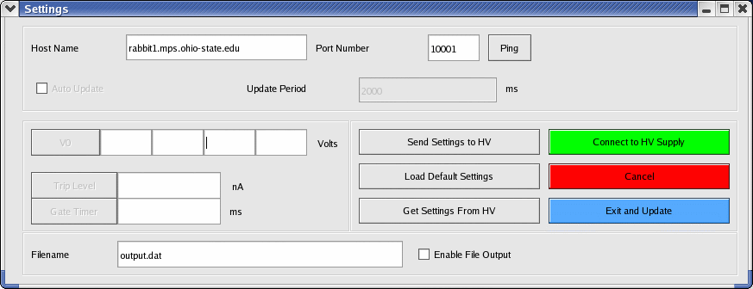

Input your HV box IP name in the Host Name field. Do not change the Port Number (the default used by the core software is 10001).

You can use the Ping button in order to check your HV box is reachable by Ethernet connection. A pop-up box will be displayed to acknowledge the successful/unsuccessful ping.

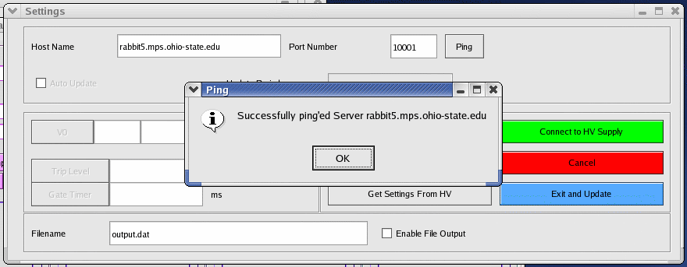

If the ping was successful, click the Connect button. The GUI will connect to the HV box and the V0, Trip Level and Gate Timer values will be loaded from the HV box and shown in the Settings panel (they will no more be grayed out):

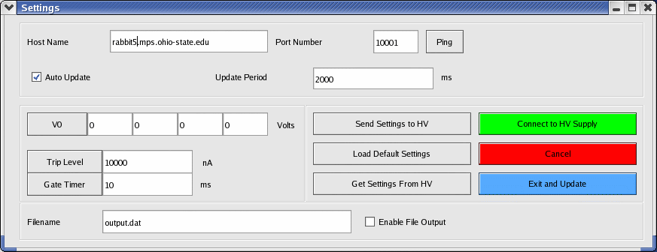
Once connected the Auto Update radio button becomes active (it is on by default once connected, but can be deactivated) and you can choose an Update Period of your choice in ms (the default is 2 seconds). It is not necessary to have the Auto Update on but if choose to deactivate it, you will have to continuously click the Read Data button in the Main GUI panel in order to update the panel data.

[In the following it is assumed that you have previously connected the 5V External Hardware Enable signal to the relevant front panel input of the HV box and that you have enabled HV control (by flipping the relevant HV Enable switch on the front panel of the HV box). You do not need to do this necessarily before connecting or reading the HV box, but in case you did not do it you will see a colorless External Hardware Disabled and a Frontpanel HV Disabled indicator instead of the expected GREEN indicators, and you will not bee able to ramp the HV until you do it.]

The connected/disconnected status is displayed in the main GUI panel X window title. After having clicked the Connect button, if the connection was successful, the main GUI panel X-window title will read Connected, if not it will stay Disconnected.

Click the Read Data button in the main GUI panel to display the current status of the HV box:

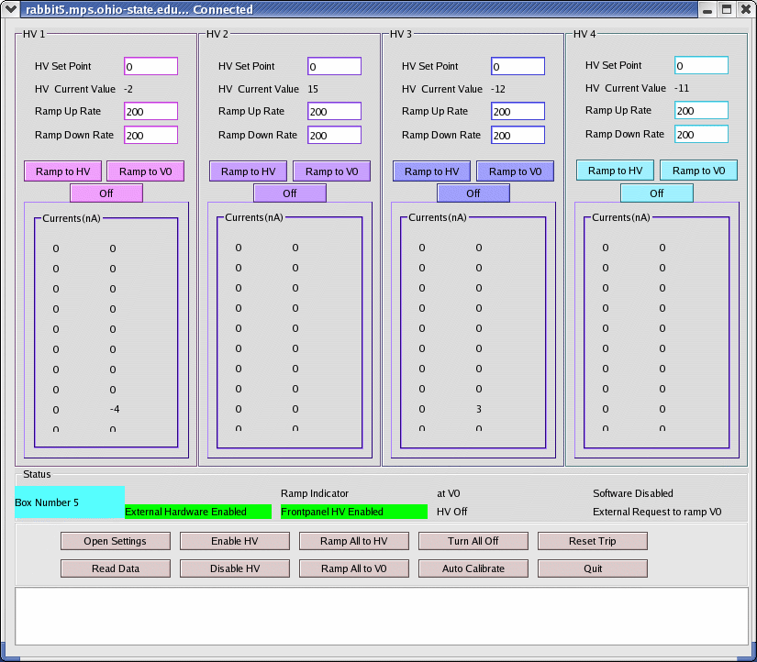
After you connected and read the status of the HV box, the main GUI panel will display in each of the sub-panels HV1, HV2, HV3, HV4, from top to bottom the default HV Set Point (in V) , the HV Current Value (in V) as read from the HV box, the default Ramp Up Rate (in V), the default Ramp Down Rate (in V), and the Currents (in nA) read from each of the 20 output channels.

[You will observe a non-zero HV Current Value even if you have just powered up the power supply and are connecting for the first time. At this time it is not possible to let the HV sit at 0V, when the external 7000V power supply is on and connected to the HV box, it is a problem we are currently working on as mentioned in the hardware documentation. In the above example the external HV was not connected to the HV box].

[You will also see the currents fluctuate around some small value].
The Status sub-panel (once again, if you have connected the external 5V enable signal and enabled the physical HV enable switch in the front panel of the HV box) will display a GREEN External Hardware Enable indicator, a GREEN Frontpanel HV Disabled indicator. There should be an HV off colorless indicator and a Software Disabled colorless indicator.

Now if the HV is off (it should be the case if you are just getting started setting up your HV for the first time!) it is recommended to click the Auto Calibrate button in order to let the box calibrate the initial offsets for all the current output channels. This operation can be repeated a few times and it takes a few seconds each time. It does not at the moment provide diagnostic to the user. The auto calibration should also be repeated each time the Gate Timer value in the Settings panel is changed.

When all 3 HV enables (External HV, Frontpanel HV and Software Enable) and all 4 HV channels are sitting at their V0 voltage (indicated in the Settings Panel) the Status sub-panel displays a RED at V0 indicator. All the other indicators should be not active. [There is a certain allowed interval of voltage around the V0 voltage set point, currently it is about +/- 50V, this can be modified in the code].

Click the Enable HV button and the Software Disabled colorless indicator will turn into a GREEN Software Enabled. Depending on the current status of the HV box and on the current settings for V0, the at V0 indicator could be on.

At this point the controls are enabled and the GUI control buttons can control the HV in the HV box .

For each single HV sub-panel, input in the HV Set Point field the desired voltage value at which you want to ramp each of the 4 HV channel. [There currently are some limitation on the minimum difference between the HV Set Point and the HV Current Value for the ramping process to start. A minimum difference of 200V is suggested, for lower increments the ramping process could fail to start because of a software feature that slows the ramping in the proximity of the HV Set Point, it will be fixed soon].

Input the Ramp Up or Ramp Down Rate to the voltage increment of your choice, these values will be used as steps in the HV ramping process.

Now it is possible to ramp all the HV channels to their respective HV set points at once by clicking the Ramp All to HV button at the bottom of the main GUI panel, or alternatively it is possible to ramp each single HV channel independently by clicking the Ramp to HV button in the relative HV sub-panel.

[Unless you have left the Auto Update radio button enabled in the Settings panel, the Status box will not be updated, and you will have to keep clicking on the Read Data button to update the main GUI panel and see the changes in HV Current Values, Currents and Status indicators].

Once any of the ramping buttons is clicked the system will start to ramp the respective channel(s) accordingly. The Status box will then display a RED Ramp Indicator. The Ramp Indicator will stay on (RED) until the desired HV Set Point is reached. During the ramping process the output channels draw more current until they stabilize at the HV Set Point. During stable HV this indicator is inactive.

The HV Off indicator from inactive will turn into a GREEN HV ON once ramping is started and HV is on. [At the moment the HV On indicator goes green as soon as any channel is higher than 500V, but this is a temporary patch and can, and will be, modified via software].

[If you try to execute HV changing commands while not all HV enables are in place a window will pop up explaining the need for the HV enable. The pop up will not explain which HV Enable is missing you will have to look at the three indicators in the Status sub-panel to find out. We are currently working to implement a new indicator for the external HV on/off. This information is not available right now. So if your External HV power supply is off you will not be notified in the Status box. The HV box will try to ramp up without success for a few seconds].

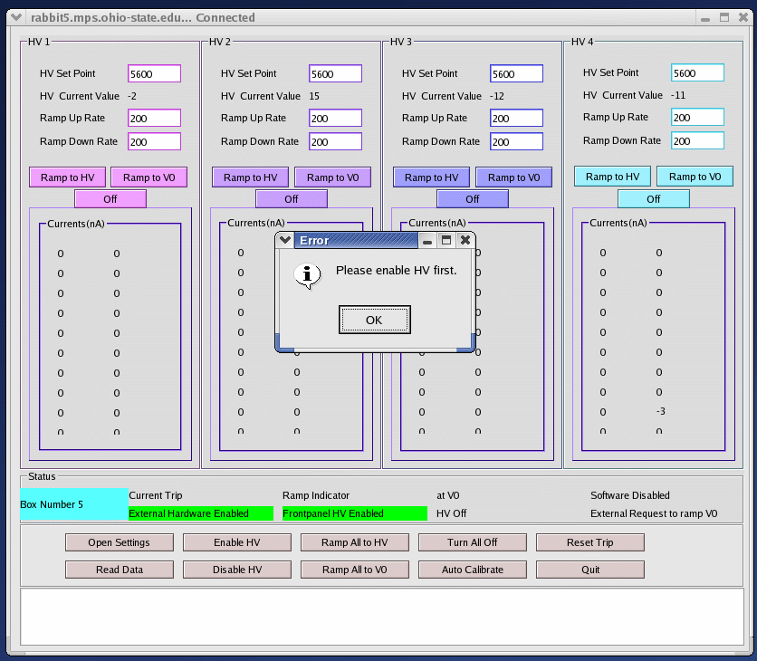
In case a current trip occurs (the Trip Level is displayed in the Settings panel) the
Status sub-panel will display a RED Current Trip indicator. In this case, at this time, all 4 HV channels are turned off and the Reset Trip button in the main GUI panel needs to be clicked to reset the trip and proceed to ramp HV. If there is no current trip this indicator is inactive.

Once the Ramp Indicator went off, each HV channel sits usually within 5V from the HV Set Point..

In order to ramp up or down each channel to any value (between 0 and 6000V) with any step, simply input the new desired HV Set Point in the relevant HV channel sub-panel field, the new desired ramp up or down rate and click the Ramp to HV button for that single channel or Ramp all to HV button to ramp all channels to their HV Set Point.

By clicking the Ramp All to V0 button, all 4 HV channels will be ramped down or (up) to their respective V0 value, as set in the Settings panel.

The V0 values can be changed in the Settings panel by simply editing them and clicking on the V0 button to the left of the actual V0 values. Alternatively any modification to the settings (Auto Update, Period, V0, Trip Level, Gate Timer, Enable File Output, Output Filename) can be loaded to the HV box by clicking the Load Settings to HV button.

It is possible to turn off each single HV channel by clicking the Off button in the relevant HV sub-panel. It is also possible to turn all channels off at once by clicking the Turn All Off button in the main GUI panel.

The Auto Calibrate feature can be used only when the HV is disabled, it tries to find the current offsets for each channel by averaging over a number of measurements done while the HV is off. You should run the auto calibration everytime you start using a box, or you modified the Gate Timer settings. [The Auto Calibrate button at the moment has just been implemented, we will probably add a diagnostic box since at the moment it gives no diagnostic to the user. More documentation to follow].

The 4 HV Current Values and the 80 Currents output channels are always monitored when connected, so the values displayed are the ones collected when the Auto Update run last or the Read Data button was clicked. At the bottom of the main GUI panel there is a message box that is supposed to show the time stamp for each command. This would also be a time stamp to know the last refresh of the data displayed in the GUI. [Unfortunately at the time of writing this feature was not working from remote (off OSU-site) so in the screenshots the message box appears empty, we are working on this].

IMPORTANT NOTE:

Disconnecting (closing) a GUI will not shut down or automatically ramp to V0, or 0V the HV box that the GUI was controlling. So after closing a GUI, just launching a new GUI and connecting it to the same IP name will enable the user to keep controlling the same HV box.

We are implementing a new safety message box that will pop-up when the user tries to quit the HVWIN program by clicking the Quit button or by closing the GUI panel X-window, while HV is ON or RAMPING.

The Main GUI HV Box Status Indicators
The Box Number field in the Status sub-panel is the number that is manually set on the black counter switch situated on the front panel of the physical HV box. This number is used to identify the box and it is read from the counter by the Rabbit core software at boot, in order to select the fixed IP address of the box to be used. (More about IP/ identification issues in the Users Manual).

Status Indicator | Description
Current Trip | No trip present, good current status for all channels.
Current Trip | At least one channel has triggered the current trip, i.e. has drawn a current higher than the Trip Limit defined in the Settings Panel (by default 10000 nA). All 4 HV channels are turned off.
Ramp Indicator | The HV is not changing, it is in a stable position.
Ramp Indicator | The High Voltage is changing, (ramping up or down).
at V0 | The 4 HV channels *ARE NOT* ALL at the reference voltage V0 specified (and adjustable) in the Settings panel. It could also be that the HV channels are at V0, but one or more of the three HV Enables (External, Frontpanel, Software) is OFF.
at V0 | All 4 HV channels are at the reference voltage V0, within an interval of +/- 60V, and all 3 HV Enables (External, Frontpanel, Software) are ON.
Software Disabled | The software enable is not set, so the GUI cannot control the HV box.
Software Enabled | The software enable has been set so if the other 2 HV Enables are present and the external power supply is ready, on and connected to the HV box it is possible to control the HV box.
External Hardware Disabled | The external hardware interlock 5V signal is not present at the HV box front panel.
External Hardware Enabled | The external hardware interlock 5V signal is present enabling the HV box to ramp up and down (assuming the other HV Enable interlocks are enabling HV ramping)
Frontpanel HV Disabled | The front panel HV enable switch is turned off (it can be important for safety during maintenance).
Frontpanel HV Enabled | The front panel HV enable switch is physically turned on the ON position.
HV off | The HV is off (channels are at less than 500V)
HV on | The HV is on, above a software limit of 500V.
External Request to Ramp V0 | External request (for future BaBar communications) to ramp to reference voltage is present

The Main GUI HV Box Panel Control Buttons

A one by one synthetic description of the buttons is still to be added, but each of them is described in the Getting Started section.

The Settings Panel

The Host Name field will contain the IP name of the HV box you need to connect.

The Port Number field should be at the moment port 10001 for all boxes, the boxes will not accept communication on other ports.

The Auto Update radio button is by default active after being connected to a HV box. Next to it is the Update Period field. [From our Windows experience the GUI may suffer space constraints on X-windows panels in Windows so that this update period field could become almost illegible for 5 digits numbers, i.e. ~10 seconds auto update periods and higher]. The Auto Update functionality is very important in order to keep the GUI data refreshed without having to click the Read Data button continuously.

V0 is a reference voltage (for now it is has no special meaning) that will be used in BaBar during injection to safeguard the LST subdetector. It can be set (independently for each one of the 4 HV channels) by editing the V0 fields (in V), one for each HV channel, and by clicking either the V0 button to the left of the 4 V0 fields, or the Load Settings to HV button. This last button is a general button that will load all the current settings (that could have been edited in the meanwhile) into the HV box.

The Trip Level field, sets the limit in current (nA) for the HV channel to trip. This one too can be reset by editing the field and click ong either the Trip Level button to the left of the 4 fields or the Load Settings to HV button.

The Gate Timer field sets the gate for the counters that measure the currents and voltages.
For now it is recommended not to change the default value of 10 ms, but higher values of the gate will allow more precise measurement (lower statistical error) at the expense of the rate of measurement that will reduce the update rate. At the moment the longest possible Gate Timer value is 50 ms, setting it to higher values will result in the value being set automatically to 50 ms. This field too can be edited and loaded singularly through the Gate Timer button, or together at once with all other changes in the Settings panel with the Load Settings to HV button. Everytime you change the Gate Timer value you should rerun Auto Calibrate from the main GUI panel

File output option and format

At the bottom of the Settings panel there is an option for writing the HV box monitoring output to a file. If you want to enable this feature, first input the name of the ASCII output file in the Filename field (remember to change the filename if you do not want to append data to it), then click the Enable File Output radio button. This feature does not necessarily need to be set before connecting and can be enabled and disable during HV monitoring, after having connected.

When the monitoring recording feature is enabled, an ASCII file with the name specified in the Filename field will be created (if does not already exist) in the local /hvGUI directory. If it already exists data will be appended to the file.

The output format is the following (obtained by running less gbenelli_test.dat):

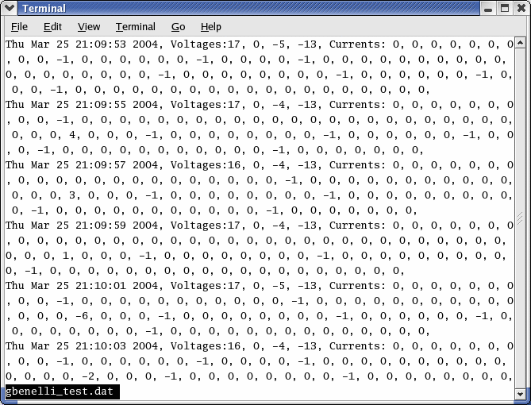

The date and time are recorded together with the voltage of the 4 HV channels, and the currents of the 80 current channels. [In the example above a partially populated test module was used, an actual working HV box woulnot show so many 0 values].

Appendix

1. CVS

The quality control software packages are kept in a cvs repository at Ohio State. You can access this from your remote machine and checkout the qc module with the following commands ( I assume you are somewhat familiar with cvs):

- Prepare your environment (it’s recommended to do this in your login file)
set your CVSROOT variable to
lst@babar1.mps.ohio-state.edu:"/net/babar1/raid0/clalf2/tem2/cvs_lst"
(setenv CVSROOT lst@babar1.mps.ohio....)
b) tell cvs to use ssh

setenv CVS_RSH ssh

c) create a suitable directory on your machine and checkout the qc files:

cvs checkout qc
d) go to the hvGUI directory. You can either start the precompiled executable directly
(./HVWin) or rebuild it with the two commands:
qmake
make

Notes:

- this is not the cleanest repository - it just has to work for a few month- so for example it includes some of executables (for red hat linux) and some object files and some of the files that could be derived from the qt .ui files.
- The password for the lst account is available upon request - just send an email to kh@mps.ohio-state.edu.
- A cvs module for the Rabbit programs will be added soon.
- In the near future the repository will move to a new host. I will inform you in time with instructions to access the modules at their new location. Please send me your email address if you want to be notified.

Remember that you will need to obtain a fixed IP address for each box and these addresses will have to be coded into the Rabbit controller core software of your box, and selected by the counter switch on the front panel of the HV box.
See the specific Settings panel section for more details.
See the Settings panel section for more details.

