BaBar LST Detector
HV Protection Circuit
S. Smith
K. Honscheid
May 2 2004
Ohio State University

As part of the upgrade of the BaBar muon detection system a new high voltage power supply has been designed. In this note we describe the over current protection circuit built into these power supplies to prevent discharges and other harmful conditions from damaging the LST detector elements. The design follows a concept developed byt the University of Padova for the ZEUS LST detector.

In addition to the traditional trip logic the O.S.U. high voltage power supplies (O.S.U. HVPS) provide a diode protection circuit for each output. A simplified schematic of this circuit is shown on Figure 1 together with a test set up that will be described later in this note.
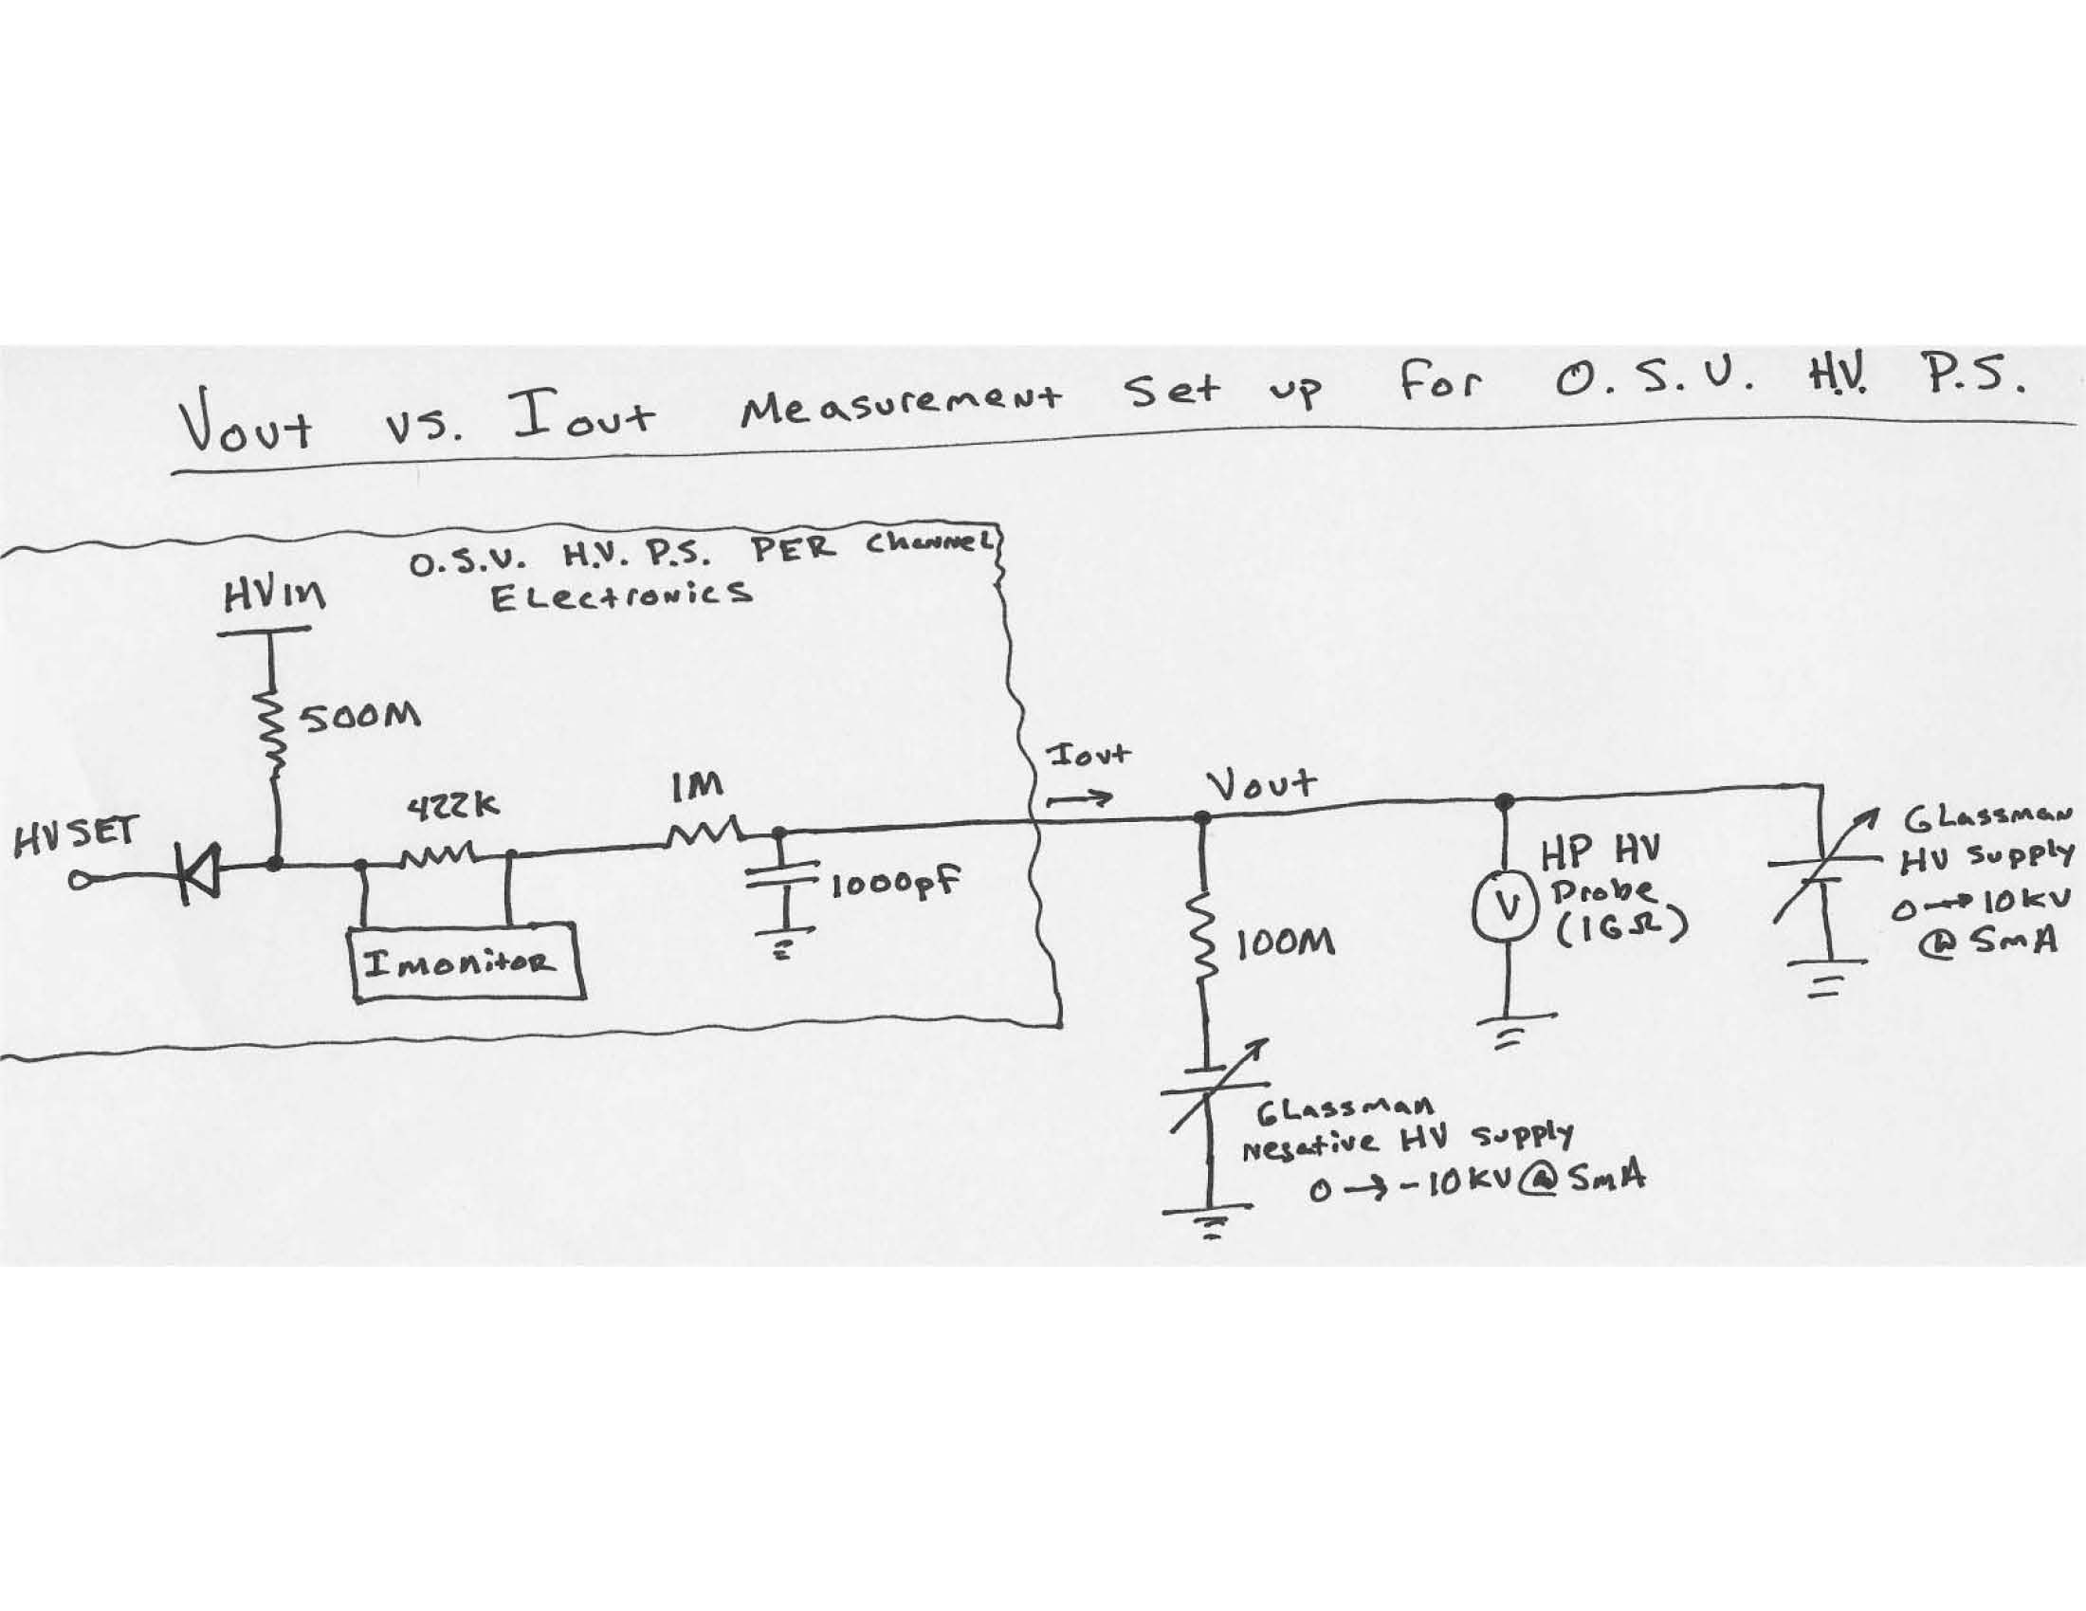

As long as the output current is small the output voltage, i.e. the voltage at the LST tube will be equal to the set point, HV_{Set}. A second voltage, HV_{In}, is set to about 1000 Volts above HVin and is connected via a 500 MOhm resistor and a high voltage diode. This diode protection circuit limits the output voltage in the event that the output current exceeds a predetermined point. This predetermined current limit (I_{Knee}) is set by the external high voltage (HV_{IN}), the output set voltage (HV_{SET}), and the 500MΩ resistor:

I_{Knee} = (HV_{In} – HV_{Set}) / 500MΩ

If the output draws a current less than I_{Knee}, the output voltage (V_{OUT}) remains at HV_{Set}. If the output current becomes greater than I_{Knee}, V_{OUT} drops linearly with a slope of -500MΩ.
To generate the V_{OUT} vs. I_{OUT} curve, HV_{Set} and HV_{In} are placed at constant values and an external high voltage power supply is placed in parallel with V_{OUT}. Also, a 100 MΩ resistor is connected from V_{OUT} to ground which provides a path for the output current that does not include either power supply. Finally, a high voltage probe is placed on V_{OUT} to monitor the voltage. V_{OUT}, determined now by the external power supply, is adjusted to HV_{SET}. Special care must be taken during this adjustment to ensure that V_{OUT} does not exceed HV_{SET} by more than 50V. The 50V limit prevents possibly damaging negative currents from flowing into the O.S.U. HVPS current measurement circuitry. With V_{OUT} at HV_{SET}, I_{OUT} measured by the O.S.U. HVPS is zero. From this point, V_{OUT} is lowered slowly and measurements of V_{OUT} from the high voltage probe and I_{OUT} from the O.S.U. HVPS are taken. Because the O.S.U. HVPS current measurement circuit has a full scale range of 12uA, the measurement is stopped when this condition is met.

The results of these measurements are shown in the Figure 2. In each case the OSU HVPS was set to 5500 V (HV_{Set}). The external voltage(HV_{In}) was set to 6500 V for one half of the tests and to 7000 V for the other. Several output channels have been tested.
We observe the expected behavior. The measurements show nice uniformity between channels. The linear drop of the output voltage with increasing current as well as the dependence of I_{Knee} on the difference between HV_{In} and HV_{Set} has been demonstrated.

