Barcode Labels for LST Tubes, Modules and Shipping Boxes

History
Back at the Rome meeting we decided to tag the components of the LST detector with barcode labels. This process starts at PHT where the tubes and shipping boxes are made. It continues at Ohio State and Princeton where the modules are assembled and it is quite conceivable that additional “tagging steps” will be performed at SLAC.
Barcodes come in all kind of formats or symbologies and Diego and Gigi have chosen the EAN-13 format. A standard barcode symbology that can represent 12 numbers but no characters. They have also defined the coding scheme for tubes and boxes that will be discussed below. Following their example I have added a coding scheme for modules. Barcode tags for other components will be defined as the need arises.

Barcodes for Tubes
The tube label encodes the tube number (unique) and the number of cells (7 or 8). Here are a few examples


Tube 251, 7 cells EAN-13 checksum Tube 23, 8 cells
Location:
One label on sleeve, one label on backward endcap (HV side). Space is quite limited on the endcaps but as the picture shows it can be done.

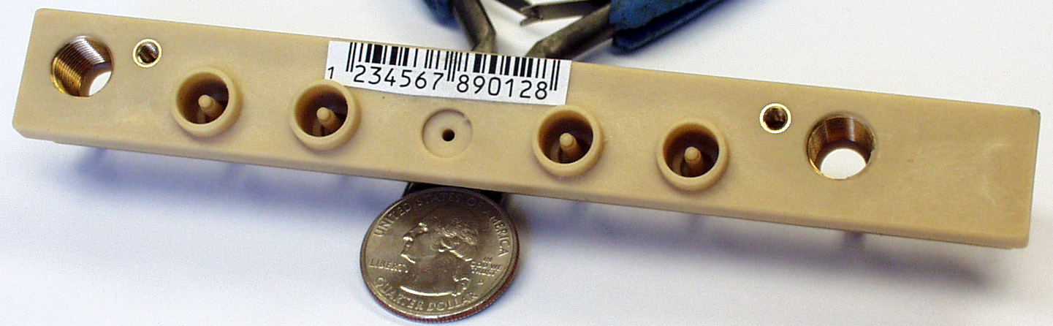

(The barcode used in the picture is just an example and not a correct tube barcode)

Barcodes for Shipping Boxes
The box label only encodes the box number. Here are some examples.


Box 53 Box 27
Location:
Each shipping box will get two labels with the box barcode and the numbers (in ASCII) and barcodes of the tubes contained in this box. Inside the box all tubes are oriented the same way, i.e. all HV ends point in the same direction. They are packaged with the HV ends of the tubes near the end of the box. Any empty space (should the box be much longer than the tubes will be on the tube ends with the forward endcaps (the non-HV endcaps). Foam or another suitable spacer material will be used to prevent the tubes from slipping during transport.
The reason for this is that we need to be able to identify tubes inside the shipping box with just the box endplates removed. For the small labels that can be places on the endcaps the scan range of our scanner is less then 2 – 3 inches
(that’s why the HV ends of the tubes need to be lined up at the end of the box).

Barcodes for Modules
The module labels encode the module number, the number of cells in the tubes (7 or 8) and the length of the module (358 cm or 318 cm). Here are a few examples
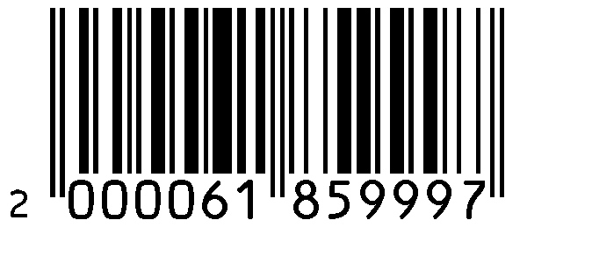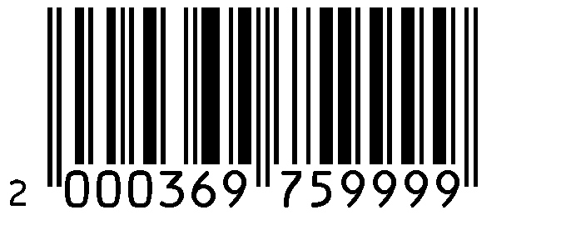
Module 61, 8 cells, long Module 53, 8 cells, short Module 369, 7 cells, long

Princeton will assemble modules 1 – 999 and Ohio State will assemble modules starting at 1000.

