Study on the Location of the HV Capacitor
Klaus Honscheid
Richard Kass
Ryan King
Chuck Rush
Ohio State University

Introduction
The baseline design of the LST detector includes a HV capacitor integrated in the HV connector so it can be located close to the tube. With this study we try to evaluate if this capacitor could be located further away from the detector, ie outside the magnet, without jeopardizing the overall performance. Besides the baseline we consider two options, an intermediate solution with the capacitors about 5 m away from the detector and a solution with the capacitors moved all the way to the other end of the 40 m HV cable where they can be integrated into the power supply.

Configuration
We use two of our three large cell prototype tubes (#10 and #13) as well as the phi strip prototype from Ferrara. The tubes are places on a grounded metal plate. We use ZEUS gas and operate the tubes at 5,700 V. A cosmic ray telescope is set up to provide a trigger.
For the first two options we use a HV distribution box that includes the 1nF HV capacitor, a 1 MOhm resistor in the HV line and 100 Ohms to ground for the wire signal pick up.

Option 1: Baseline
25 m Kerpen HV cable between CAEN HV supply and HV capacitor box, the box is located directly next to the tubes.
The follwing pictures show ten typical pulses:
yellow = gate (cosmic ray trigger)
blue = wire signal (for the channel covered by trigger counters)
purple = strip signal (for the channel covered by trigger counters)
green = neighboring strip (to check cross talk)

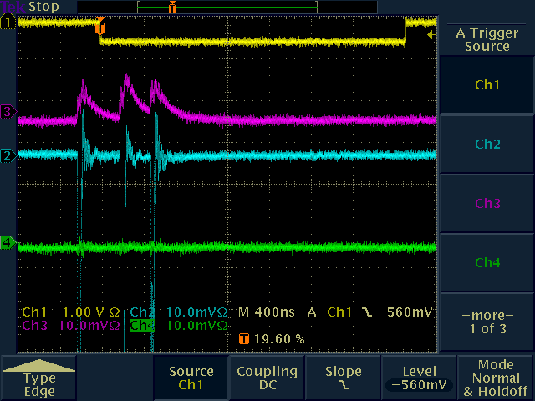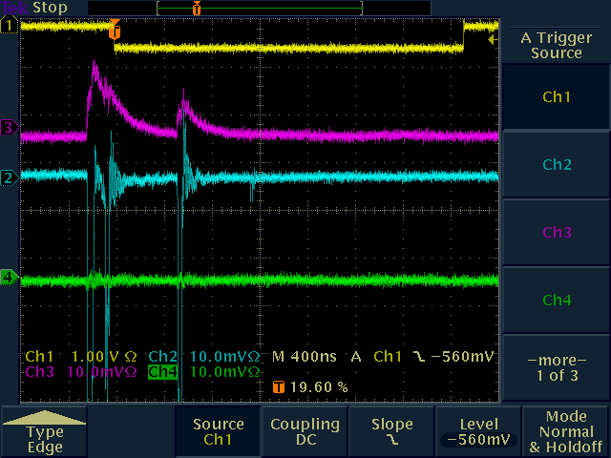
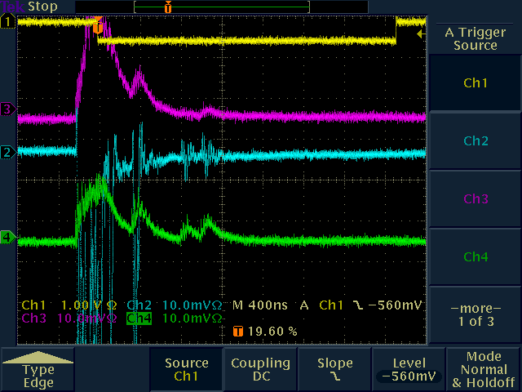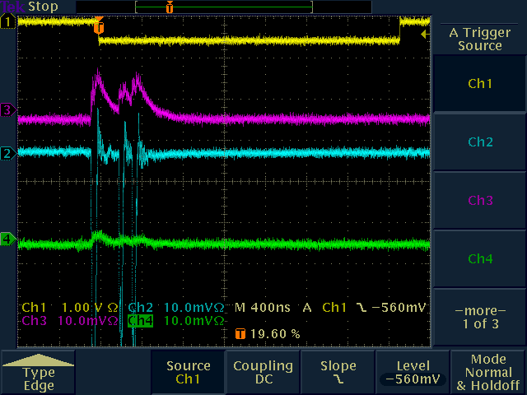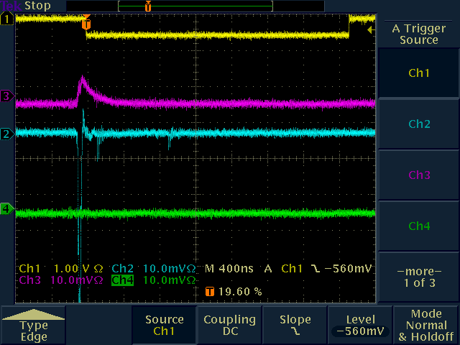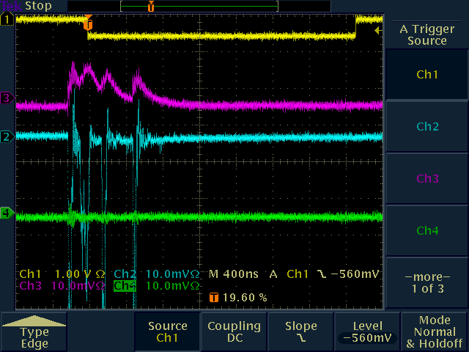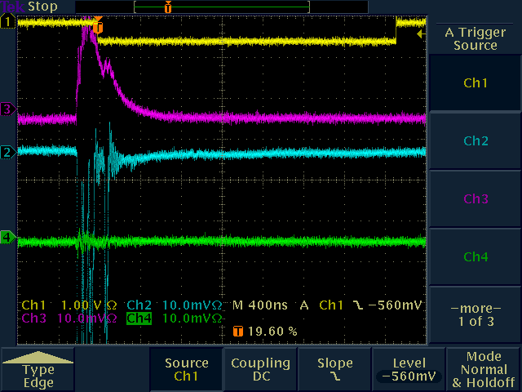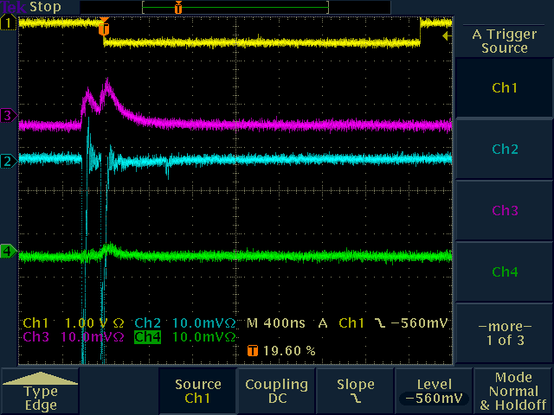
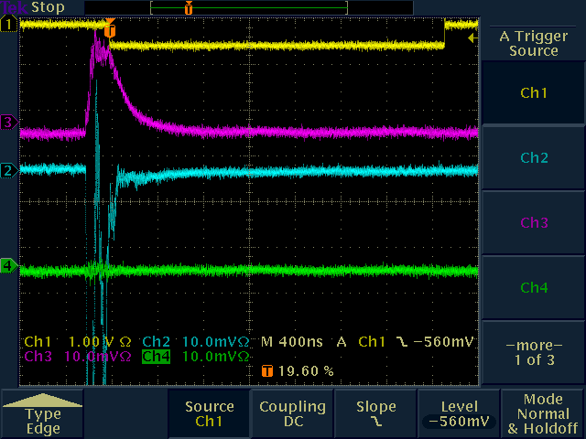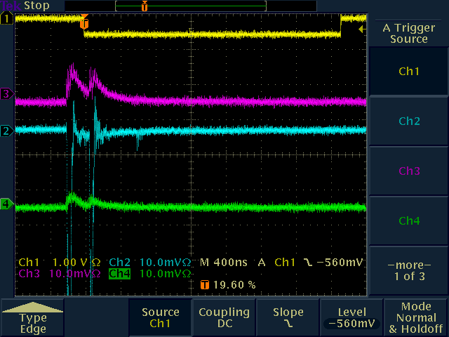

Observation:
Nice coincidences between wire and strip signals (blue + purple). Some cross talk in neighboring strip (green) – as expected from the capacitive coupling. This is the configuration currently installed in BaBar (test tube) and we know that it works.

We further studied the performance of the base line solution by recording the pulses (green trace) from a far away strip and not from a neighboring channel (same tube, other side).
Here are 10 typical scope pictures.
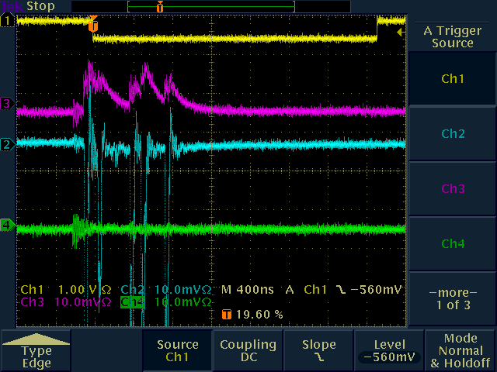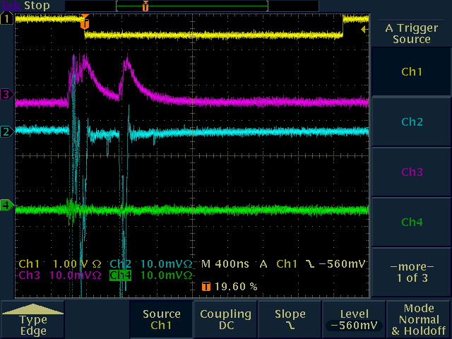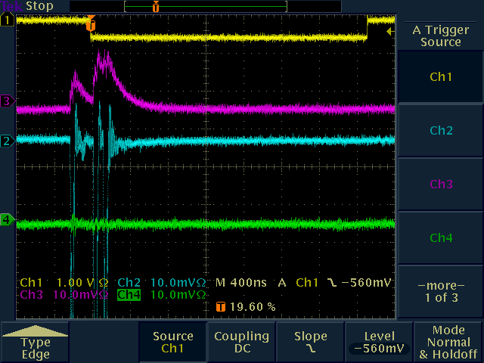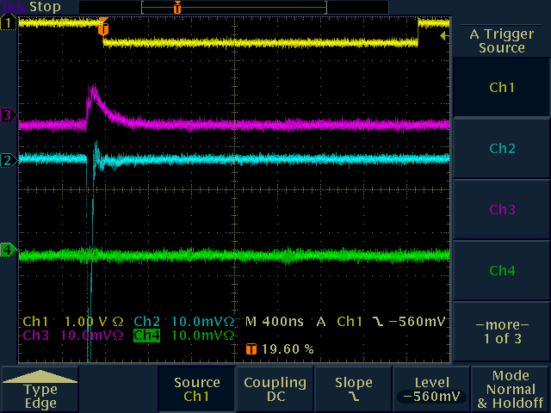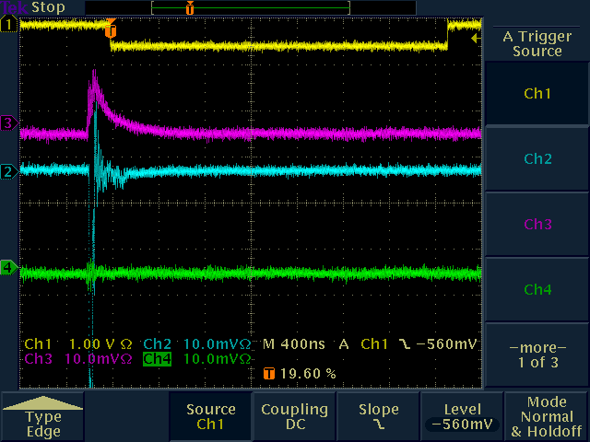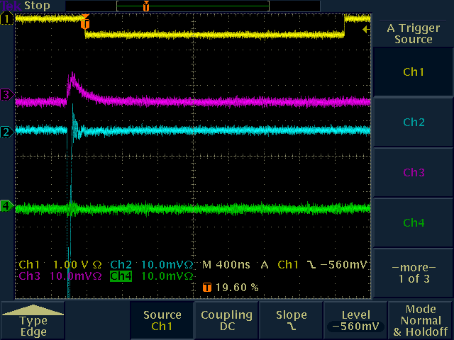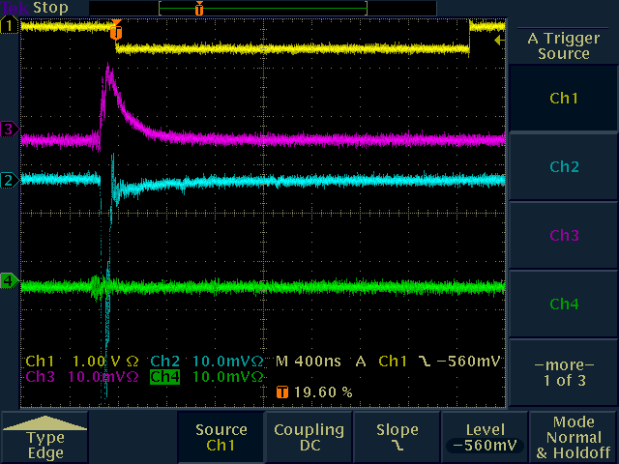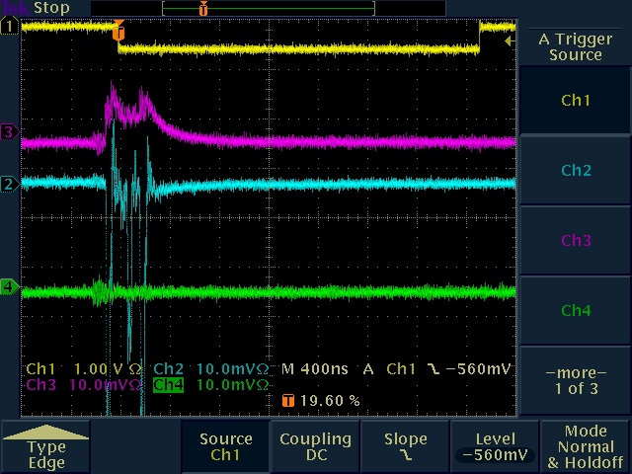
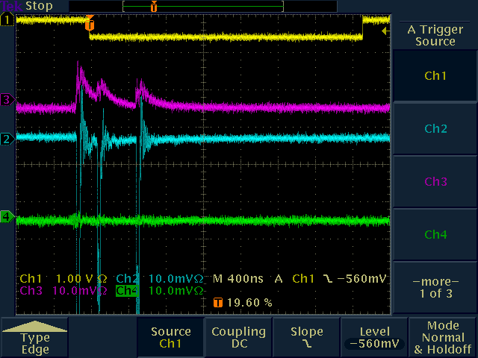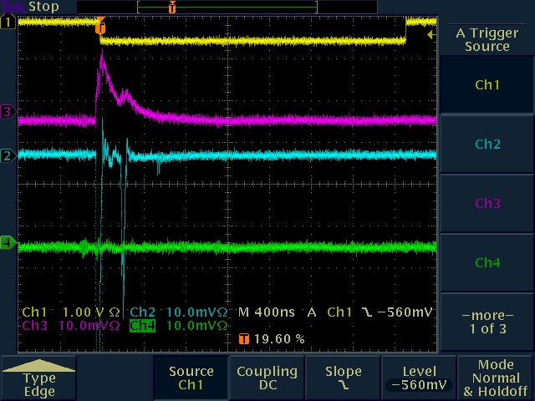

Observation:
As before, reduced cross talk (green) as expected.

Option 2: HV capacitors just outside the magnet
25 m Kerpen HV cable between CAEN HV supply and HV capacitor box.
5 m Kerpen HV cable between HV Capacitor box and tubes.

Ten typical pulses:
yellow = cosmic ray trigger
blue = wire signal (for the channel covered by trigger counters)
purple = strip signal (for the channel covered by trigger counters)
green = neighboring strip (to check cross talk)

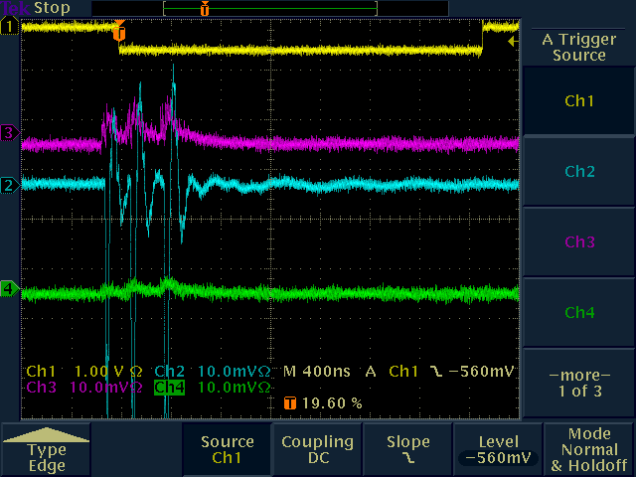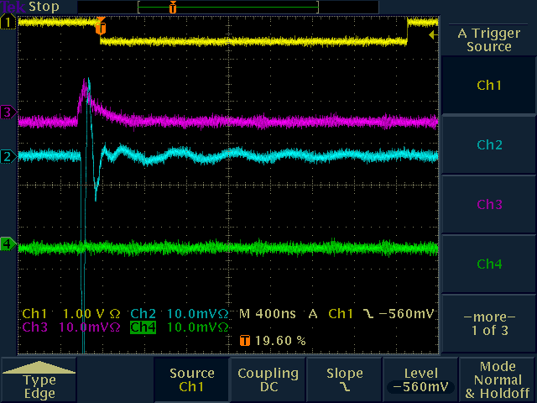
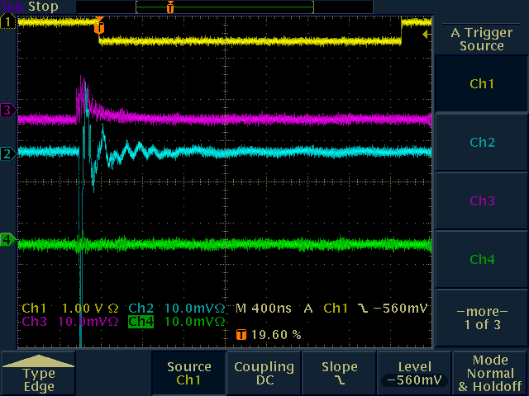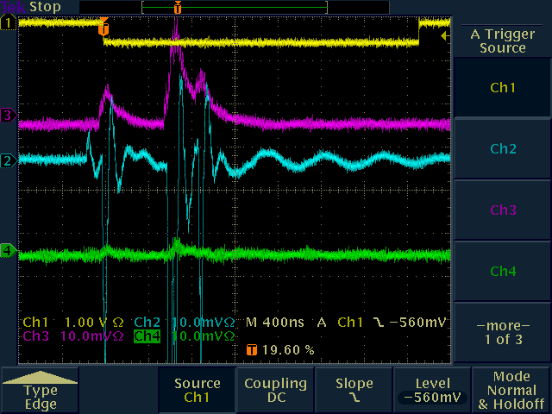
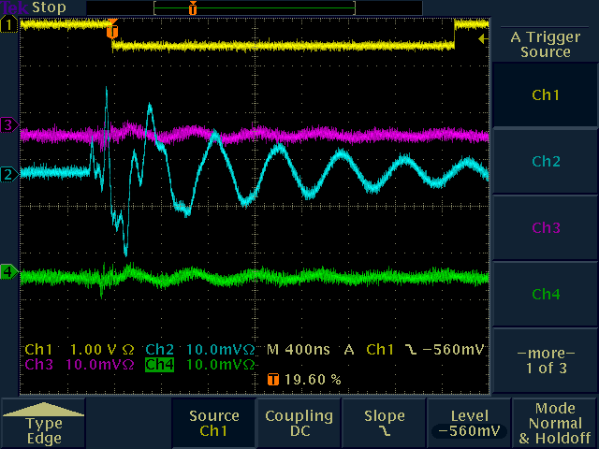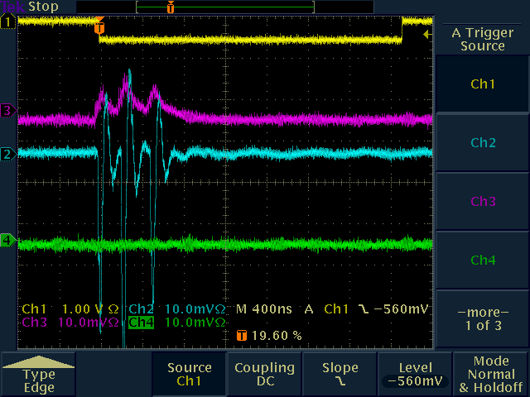
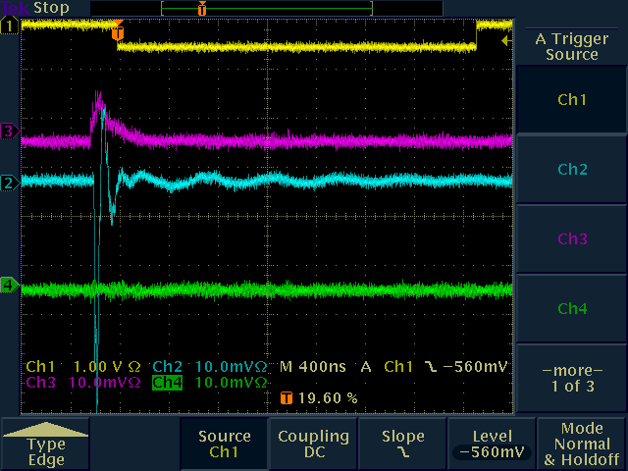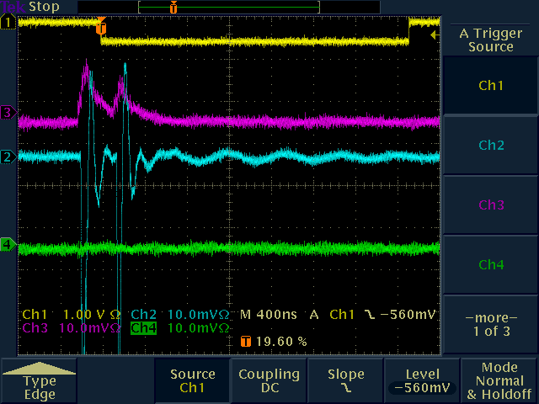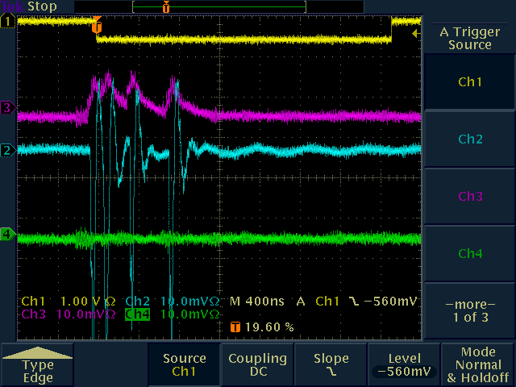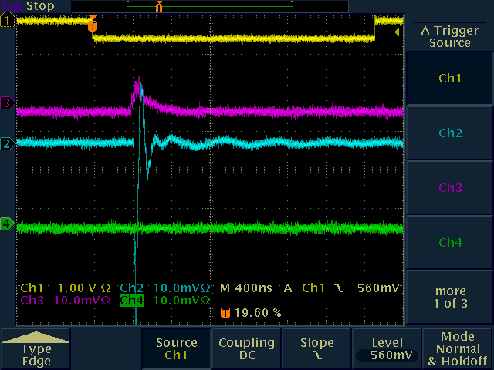

Observation:
Nice coincidences between wire and strip signals (blue and purple). Very little cross talk (green). Noticeable ringing on wire signal trace (blue). Also on some of the strip signals, e.g. scope picture #5.

Again we ran a second test recording the pulses from a strip far away from the trigger counters (same tube, other side).
Here are 10 typical scope pictures

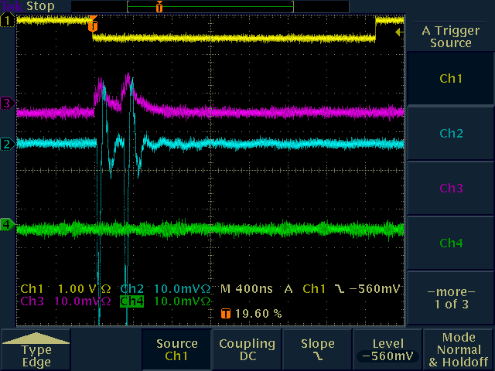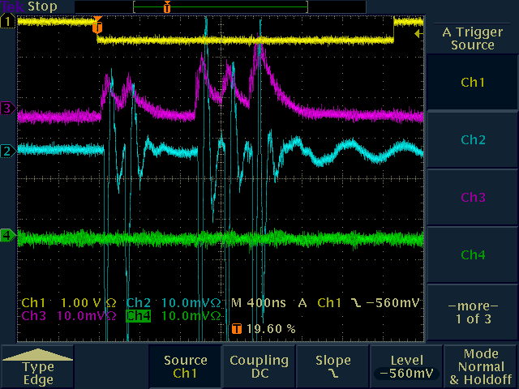
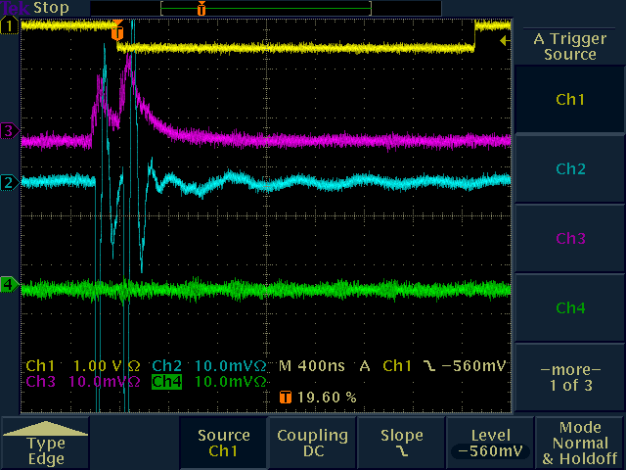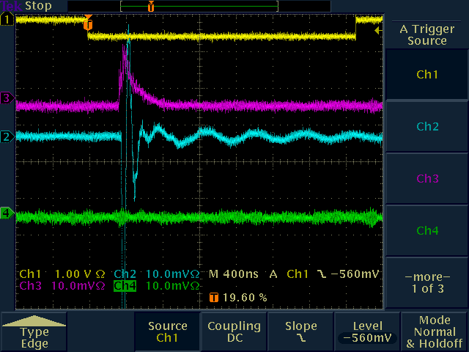
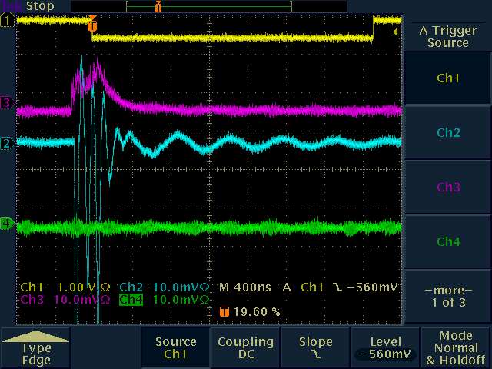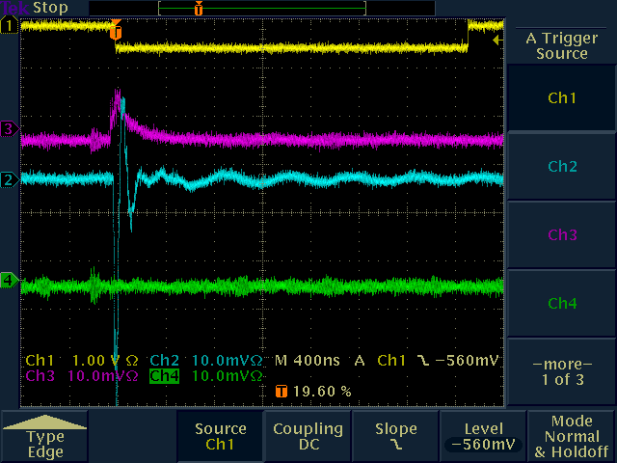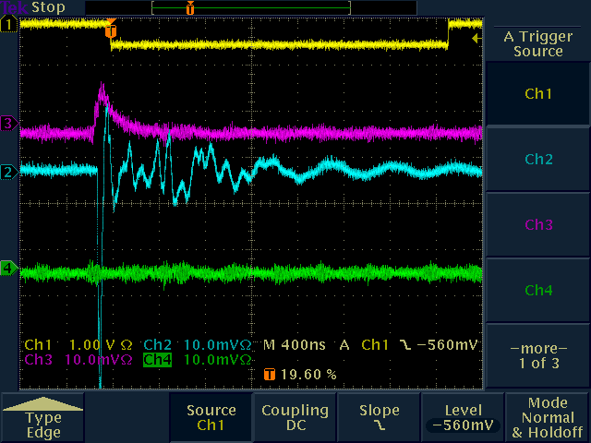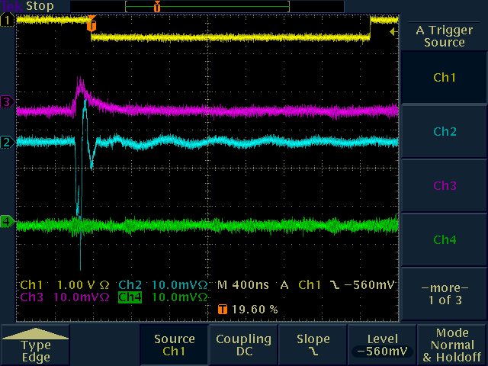
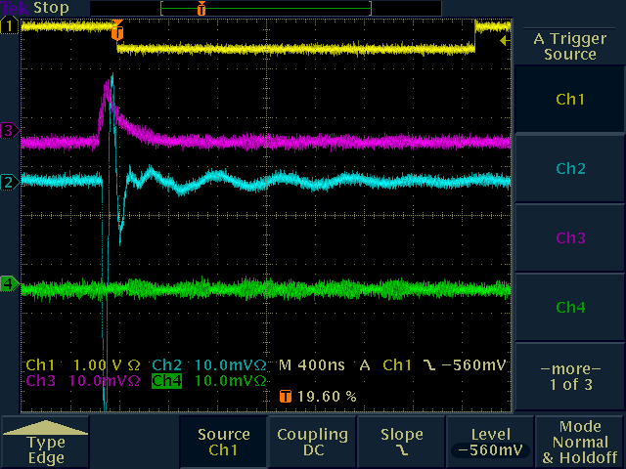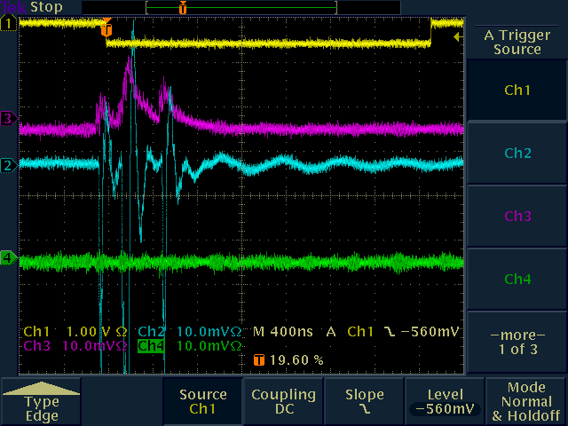

Observation:
Same as above.

Option 3: HV capacitors at the far end of the HV cable (at the power supply)
CAEN HV supply, HV capacitor to ground, 82 Ohm series resistor, 45 m Kerpen HV cable directly plugged into the tubes. No wire readout.
Ten typical pulses (the vertical scale is 10 mV for the green, blue and purple traces)
yellow = gate (cosmic ray trigger)
green = far away strip (to check cross talk)
blue = strip signal (for the channel covered by trigger counters)
purple = neighboring strip (to check cross talk)

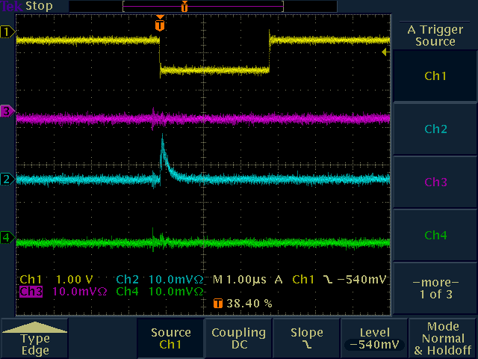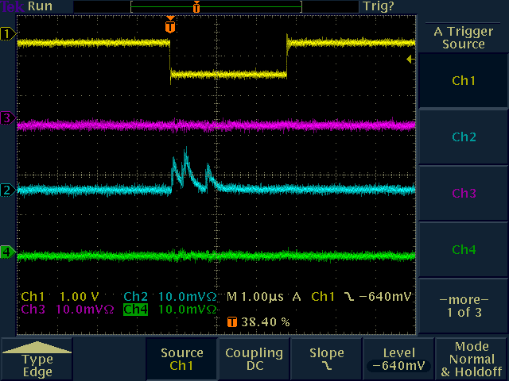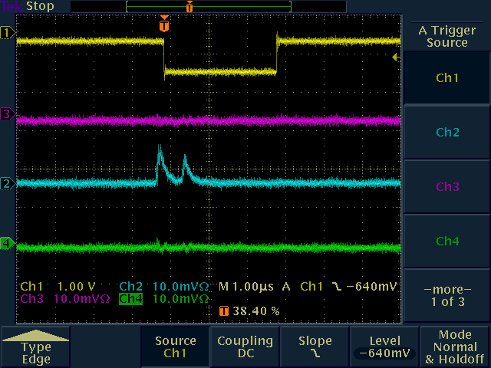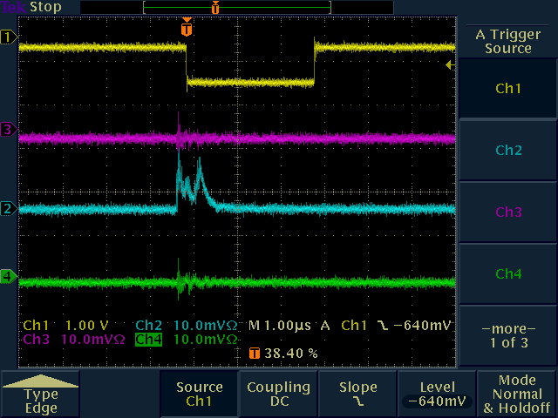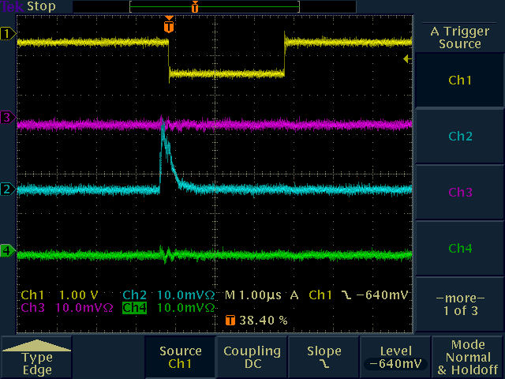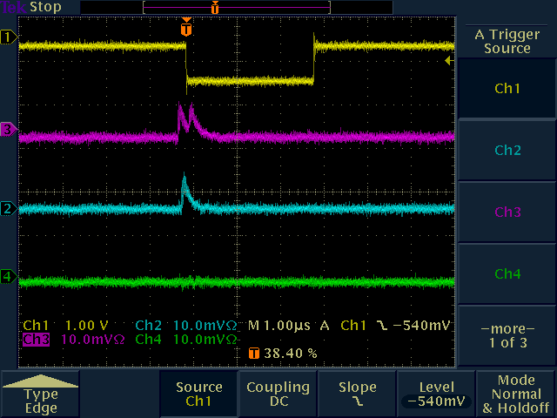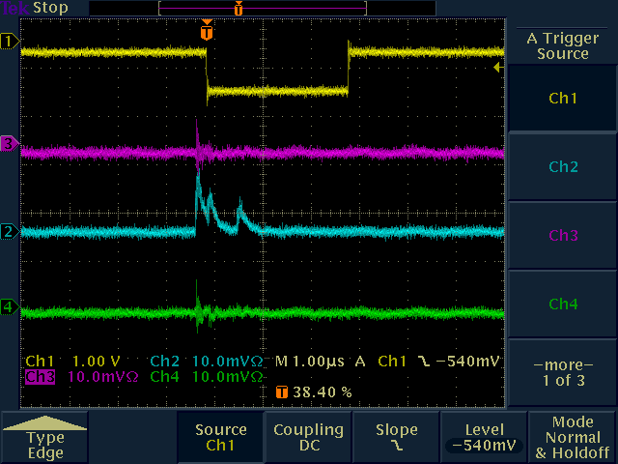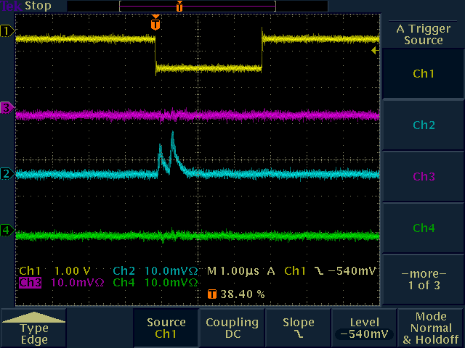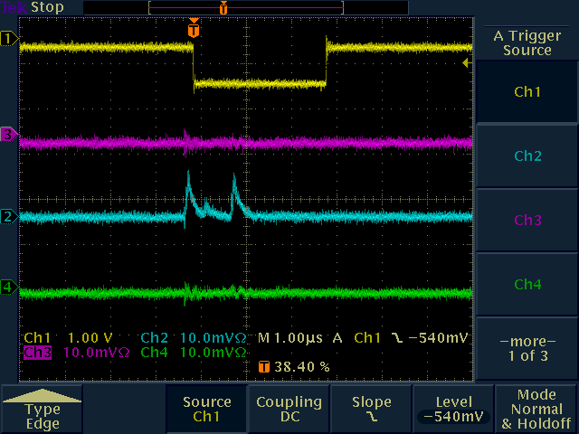

Same configuration as before but this time without the 82 Ohm termination resistor.
Ten typical pulses (the vertical scale is 10 mV for the green, blue and purple traces)
yellow = gate (cosmic ray trigger)
green = far away strip (to check cross talk)
blue = strip signal (for the channel covered by trigger counters)
purple = neighboring strip (to check cross talk)

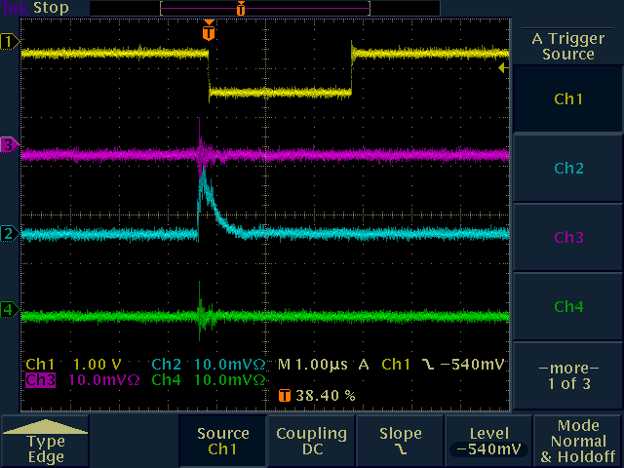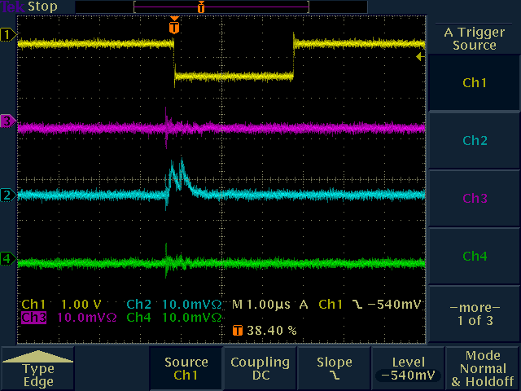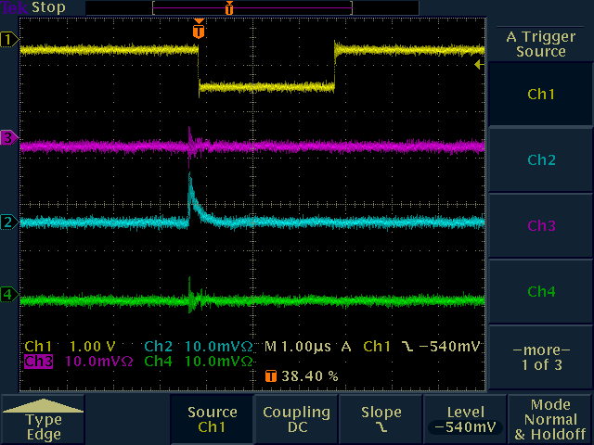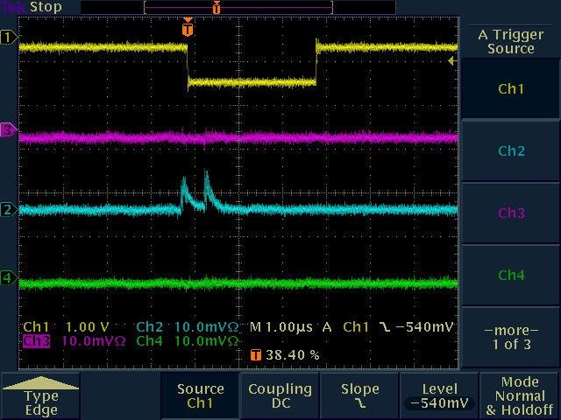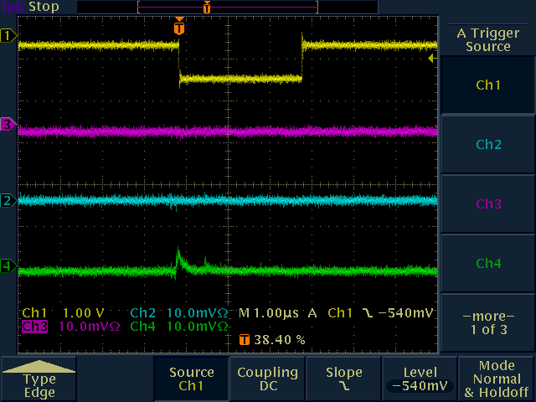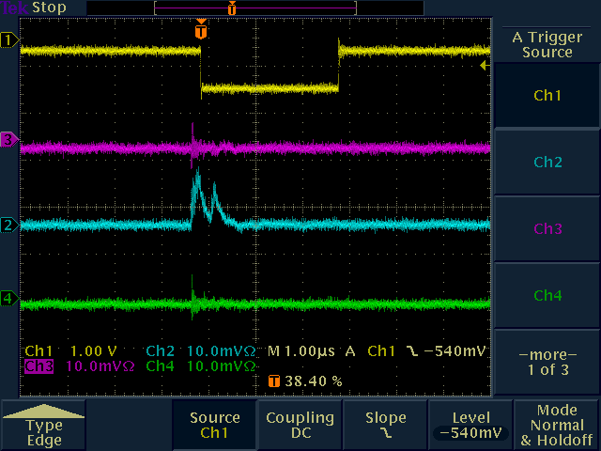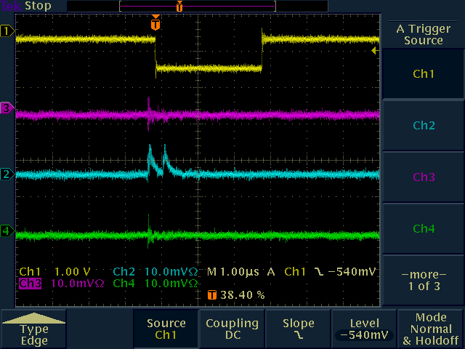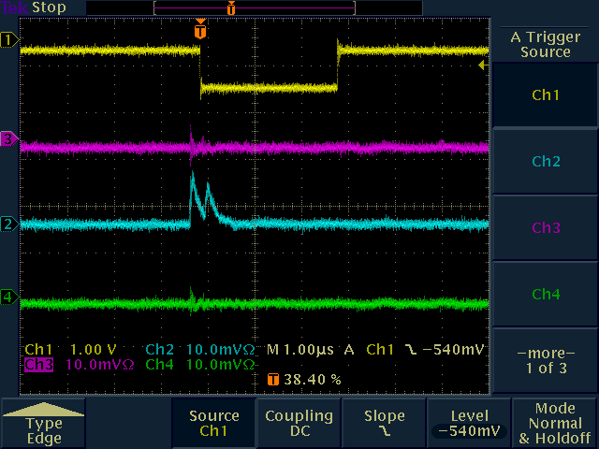
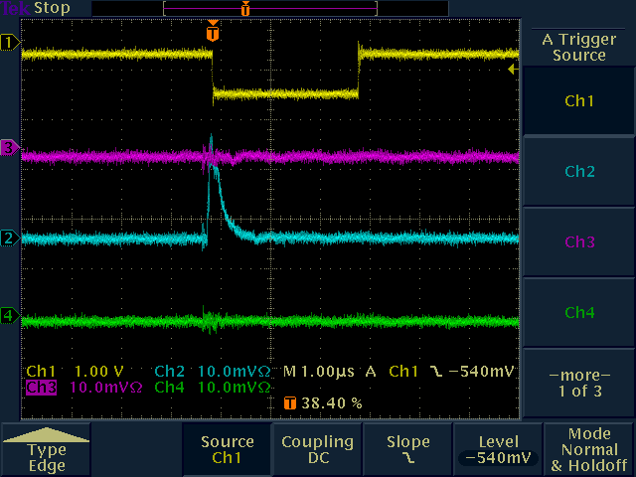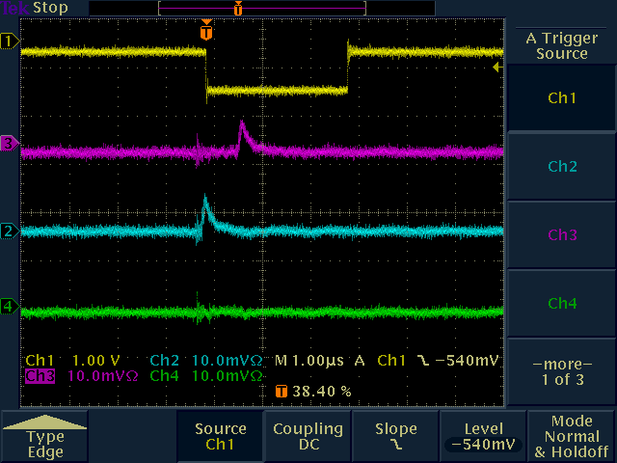

Modification:
45 m cable, 82 Ohm termination at the power supply end (as in the first test of option 3). In addition, we have a 1 MOhm resistor in the HV line (after the HV capacitor) to simulate the output stage of the OSU HV power supply.
Ten typical pulses (the vertical scale is 10 mV for the green, blue and purple traces)
yellow = gate (cosmic ray trigger)
green = far away strip (to check cross talk)
blue = strip signal (for the channel covered by trigger counters)
purple = neighboring strip (to check cross talk)
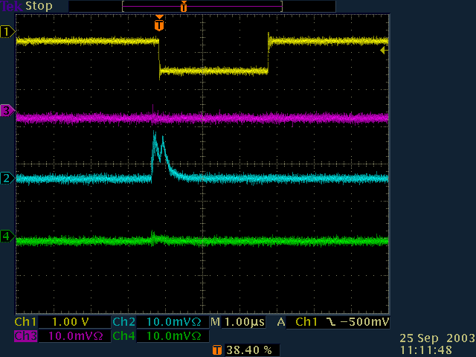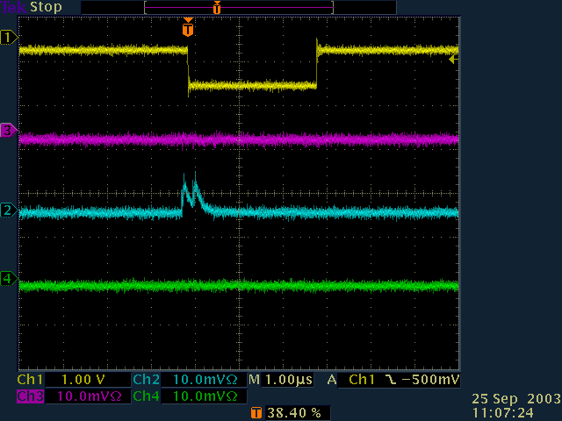

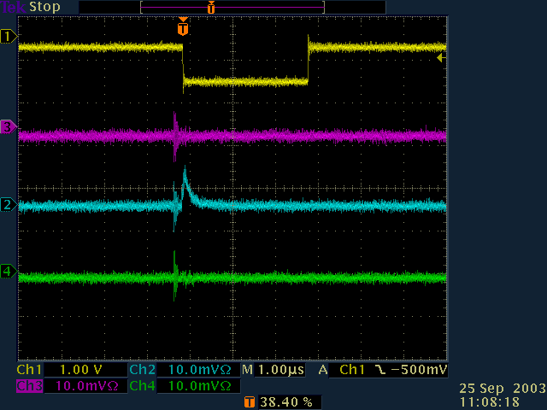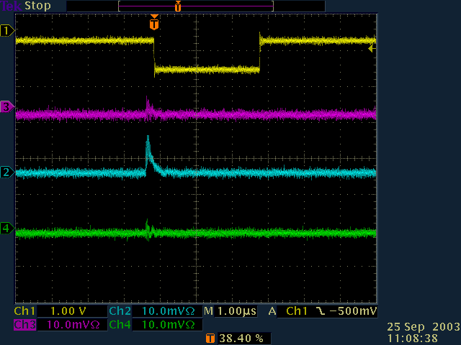
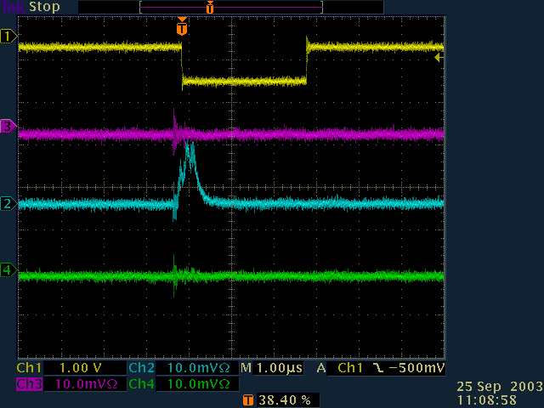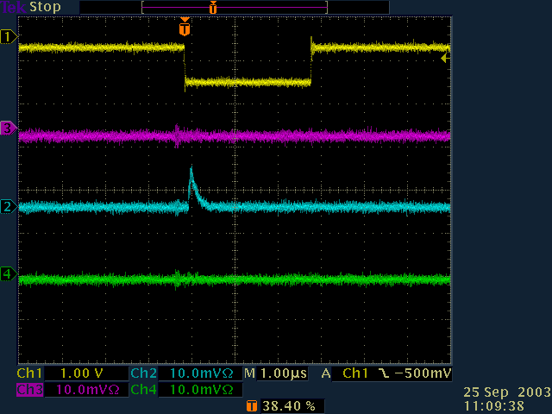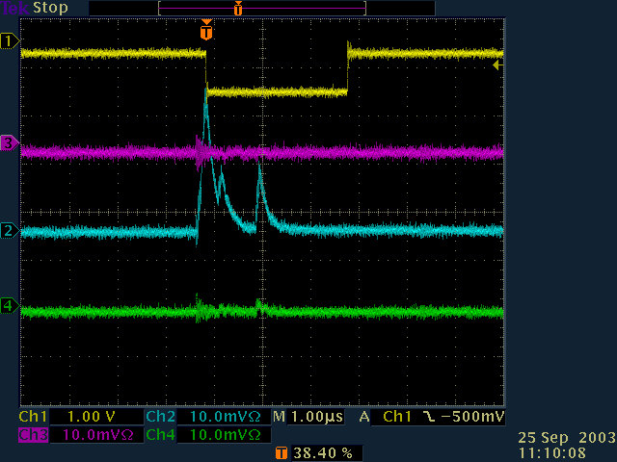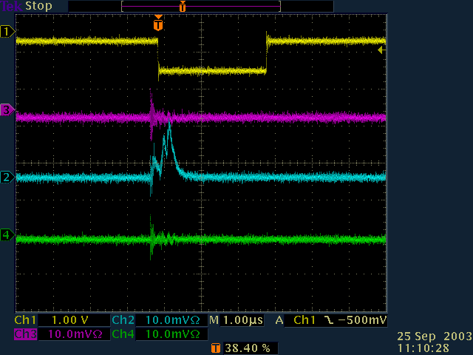
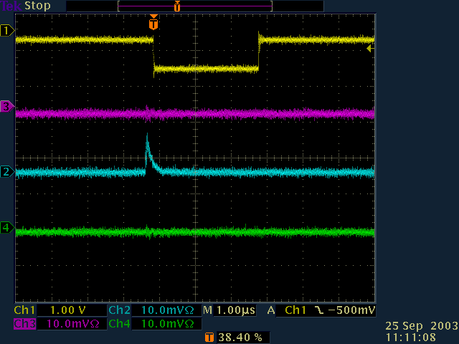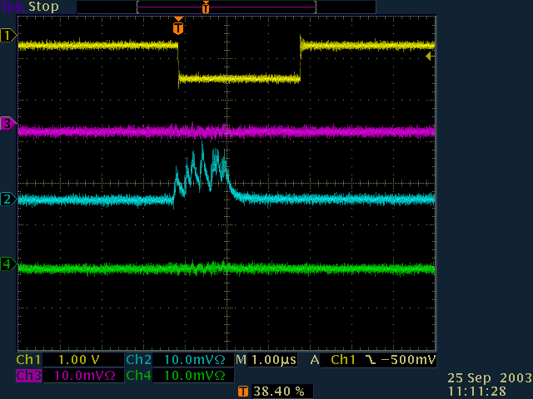

Not much of a difference can be observed.

Pulse Height Spectra
Using a LeCroy Fastbus ADC (1885) we recorded the strip signals to compare pulse heights in the different configurations. Right now, our Fastbus system is not calibrated and the timing of the gate has not been optimized.

Our pulse height system is not working and I have removed the measurements from this report. I will try to correct this next week and add this information back in.

Cross Talk Studies
Before we studied option 3 above we did a few measurements to determine the properties of the Kerpen HV cable.

Using a pulse generator we determined the cable impedance by finding the proper termination resistance. The sketch of the setup is shown here
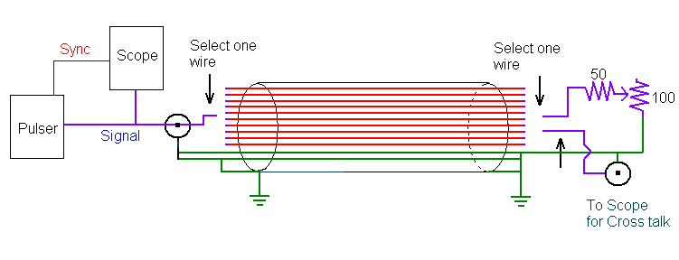
The Kerpen cable is not a coax cable and hence does not provide constant impedance. The impedance of a particular wire depends its location with respect to the ground shield and the ground wires in the cable bundle. We picked a random combination and checked some ten wires to obtain the following results:

We slightly modified our setup and measured the cross talk with respect to wire #9. The input pulse height was set to 2 V.

Except for wire #10, ie the neighboring wire the cross talk is very small.
This test measures the wire to wire cross talk. We are more interested in the wire to wire to strip cross talk. To study this effect we brought our setup to the LST tubes. With one wire of the Kerpen cable connected to the pulse generator and another wire connected to a HV pin in the tube endcap we record the signals on the strip above the corresponding wire.

Configuration:
Pulse generator (1 V peak, 2 ns rise time, 3 mu-sec, yellow trace, 2 V scale) -> HV cable (wire 16, open end)
Wire #6 plugged into LST tube #13, channel B
Observe pickup on phi strip above this wire (blue trace, 5 mV scale)
The picture shows the worst case scenario. Every other combination was way below 5 mV.

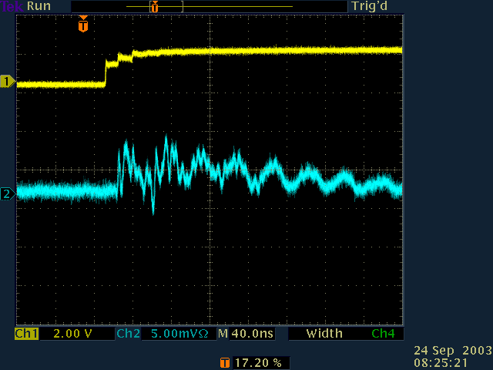

Same configuration but wire #6 and #16 are now connected at the far end (which would be the case if the two wires share the same HV channel).
Input pulse height reduced to 100 mV (left). The results for a 1 V input pulse are shown in the right plot. (blue trace, 5 mV scale)

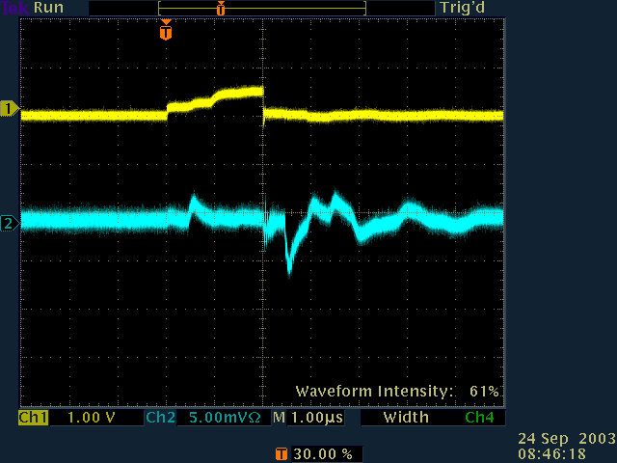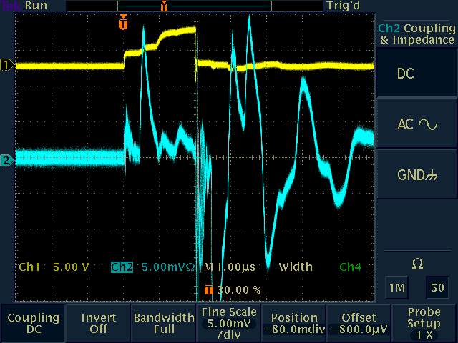

Same as above (1V left, 100 mV right, but we record the signal form a strip further away (4 sections))

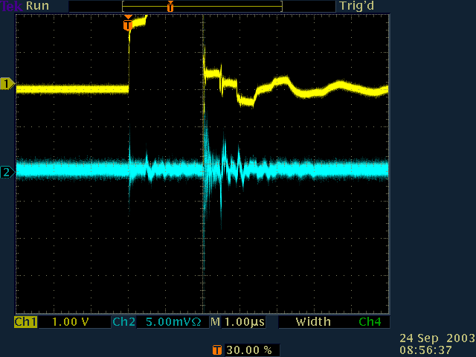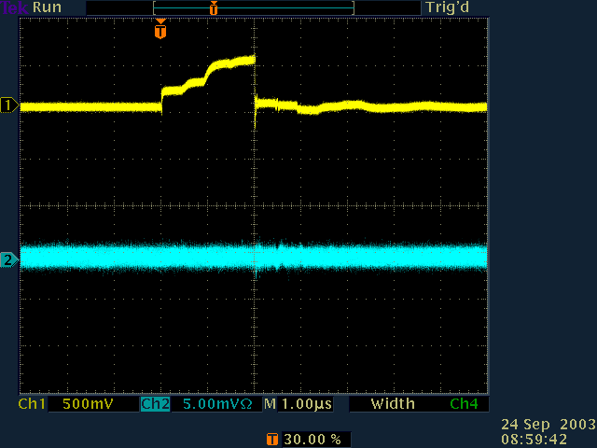

Same configuration but wire #6 and #16 are terminated with 82 Ohm (in line) at the far end (power supply). Input pulse height reduced to 100 mV (left). 1 V is shown in the right plot.
The yellow trace is the input pulse. Just to be confusing we changed the other colors for the 2 plots. On the left, the blue trace is the strip pickup signal for the terminated configuration, white shows the same but without the termination resistors. On the right plot, the white trace is the signal for the terminated configuration, blue is without the resistors. Notice the different y scales for the blue and white traces (5 mV left, 20 mV right).

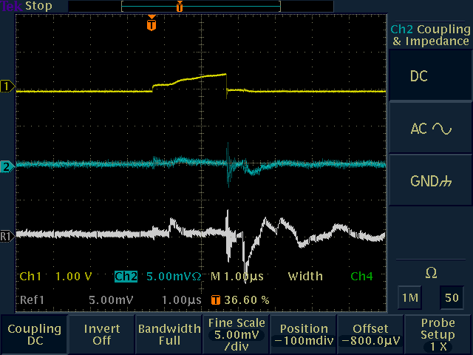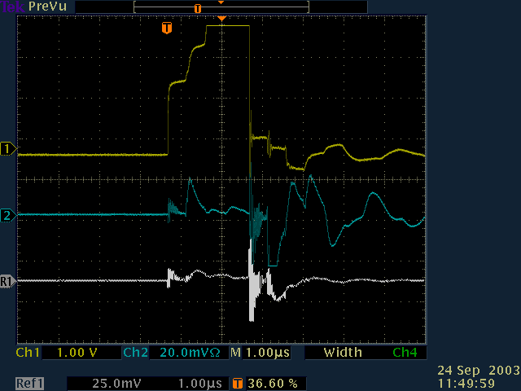

The observed cross talk is very small. It can be further reduced by terminating the HV cable at the power supply end with 80 – 100 Ohm which matches the average impedance.

Conclusion
Based on these tests we have not discovered any reason why the strip readout should not work with the HV capacitors located at (or in) the HV power supplies, 45 m away from the detector.
If we seriously consider this option we should try to get a real test setup at SLAC using one of the 2 tubes in the test module.

