Fiber Installation Notes (Revision 2.2)

Scope:
DAQ path fiber optic cables.
From: Mini-rack fiber cassettes.
To: FED rack fiber cassettes in USC55 (S1G06, 07, and 08).

Notations and Conventions:
In USC55:
The fiber cassette crates in the FED racks are denoted as FCTC-1 through FCTC-12 where FCTC stands for Fiber Cassette Termination Crate.

In UXC55:
There is one fiber cassette crate per mini rack. So only the mini-rack label is used to specify the fiber cassette crate (ex: X5U41).

The cassette positions within a crate are numbered from 1 to 12 with position one starting on the left. Cassette positions are indicated in parentheses and appended to the crate name. So FCTC-7(3) specifies the cassette in position 3 of crate 7.

Connectors:
All connectors on the DAQ path fiber cassettes are to be LC receptacles.

Fiber Terminations:
The DAQ fibers are provided in one 24-fiber bundle per peripheral crate which means that there are two bundles per mini-rack (with the exception of YE3 (station 4) which only has one bundle per mini-rack).

Each 24-fiber bundle is terminated in a pair of 12-fiber cassettes on each end. On the mini-rack end, the cassettes in the pair are in adjacent positions in the crate. On the FED rack end, the cassettes in the pair are in the same position in two crates one directly above the other.

For YE1 and YE2, the mapping for terminating each fiber in a bundle is 1-to-1 with all fibers terminated. See the diagram and table in Fig. 1 and Fig. 2 for details.

For YE3, only 12 of the 24 fibers in the bundle are used and the mapping is also 1-to-1 but some cassette termination positions are left unconnected. See the diagram and table in Fig. 3 and Fig. 4 for details.

Mapping of Cassettes:
Table 1 specifies which mini-rack cassette is to be connected to each of the FED rack cassettes. For convenience the reverse mapping is listed in Table 3 (which FED rack cassette is to be connected to each mini-rack).

Observations:
- This configuration of fiber terminations requires a total of 240 12-fiber cassettes and zero 6-fiber cassettes, which differs from the original quote.
- With the exception of YE3, we are requesting that all 24-fibers in a bundle be terminated at both ends, which again differs from the original quote which only terminated the minimum number necessary.

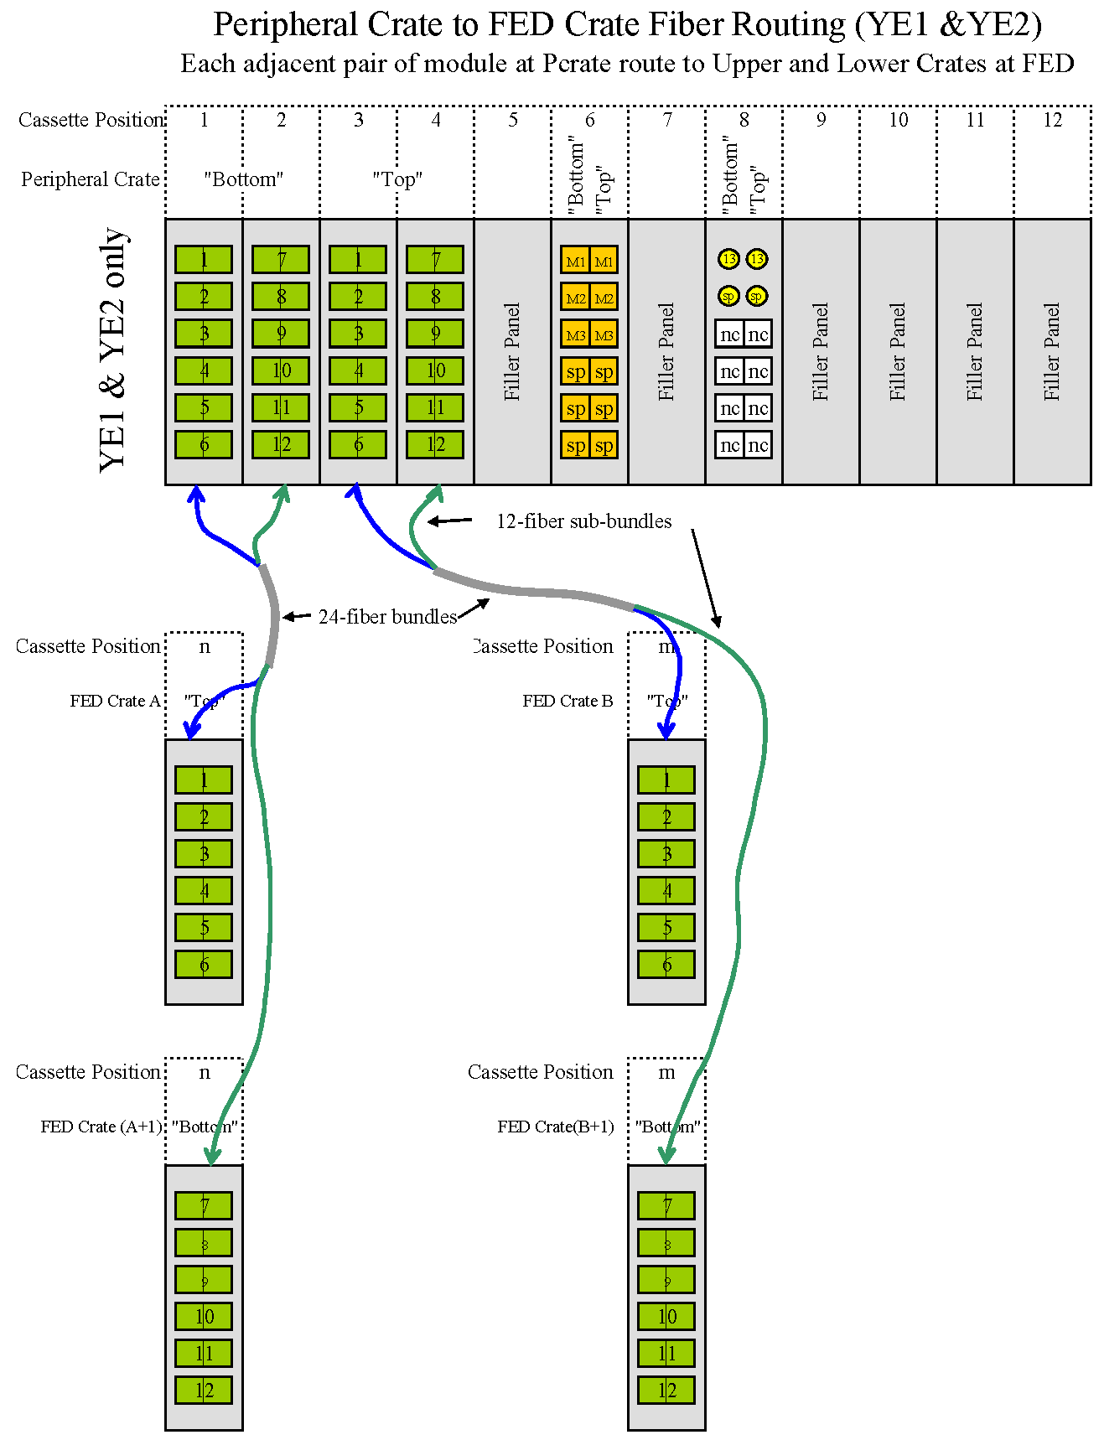
Figure 1
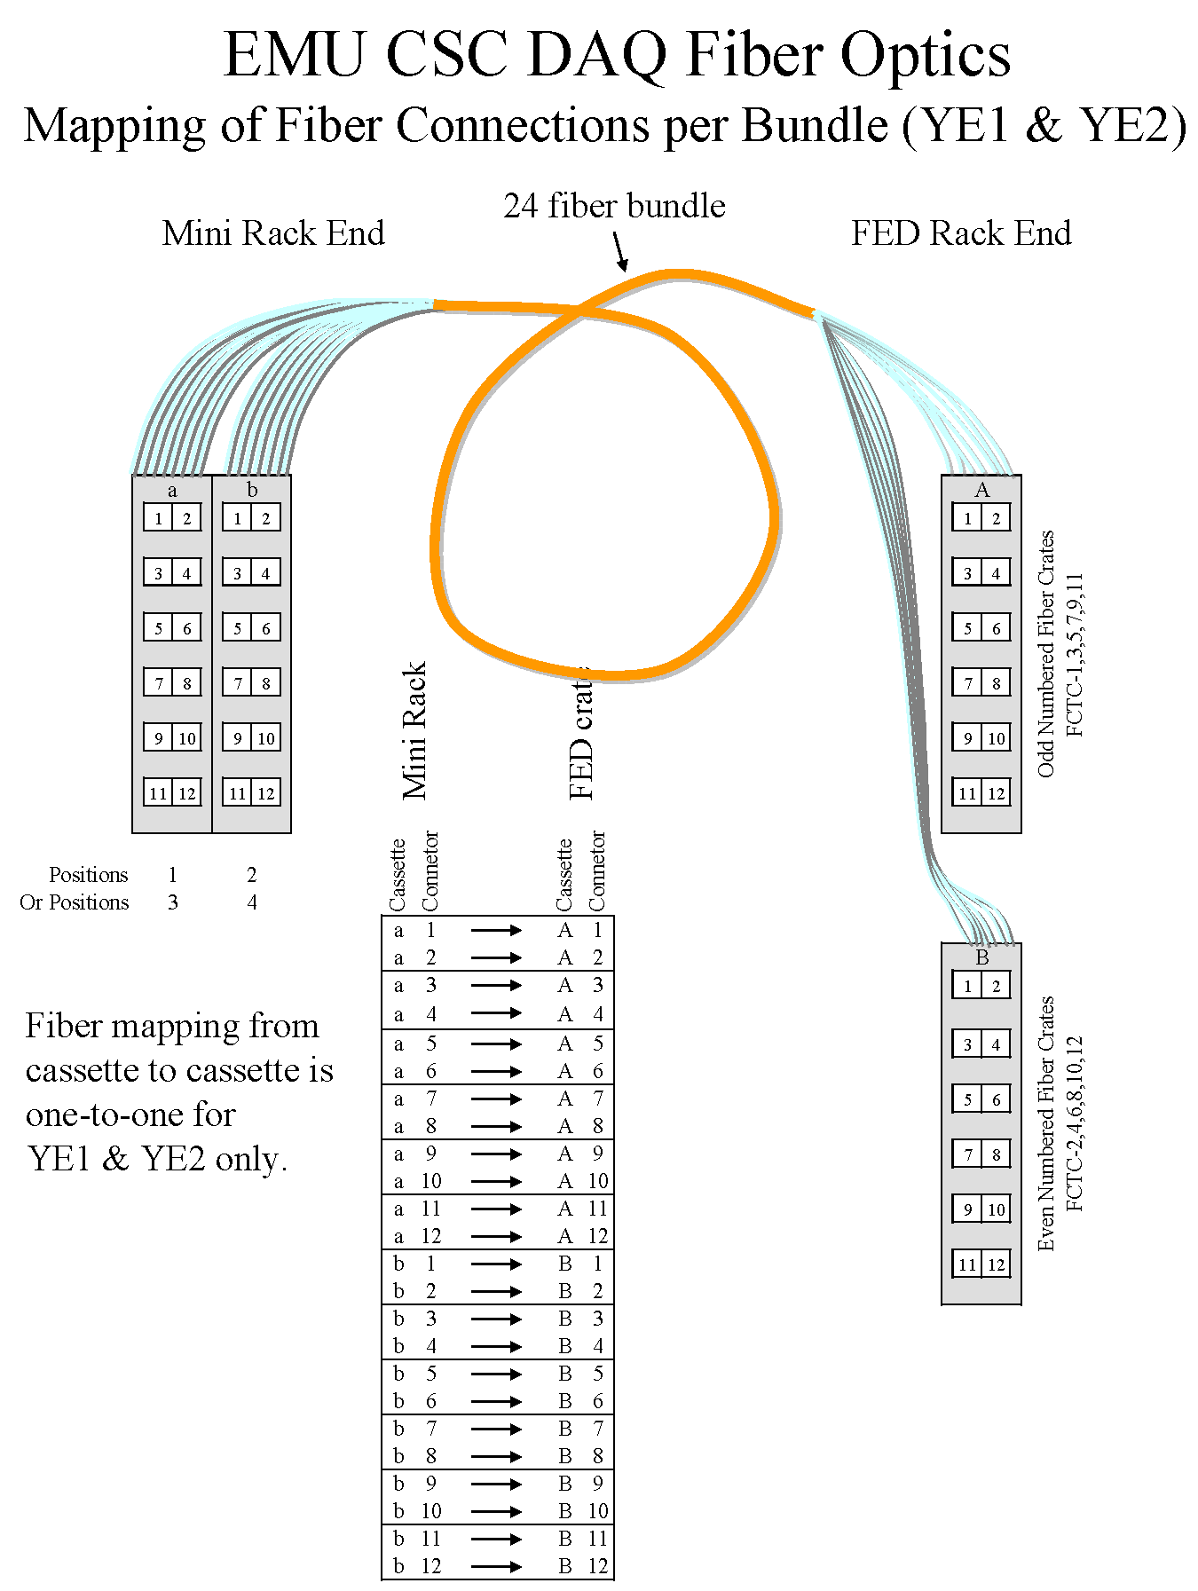

Figure 2
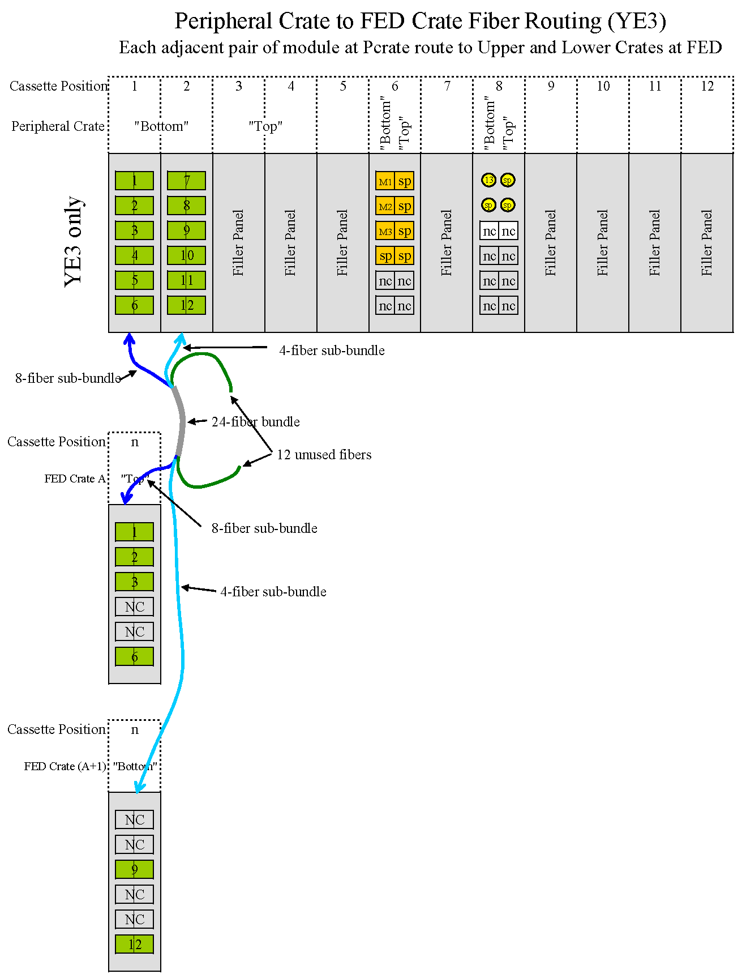
Figure 3
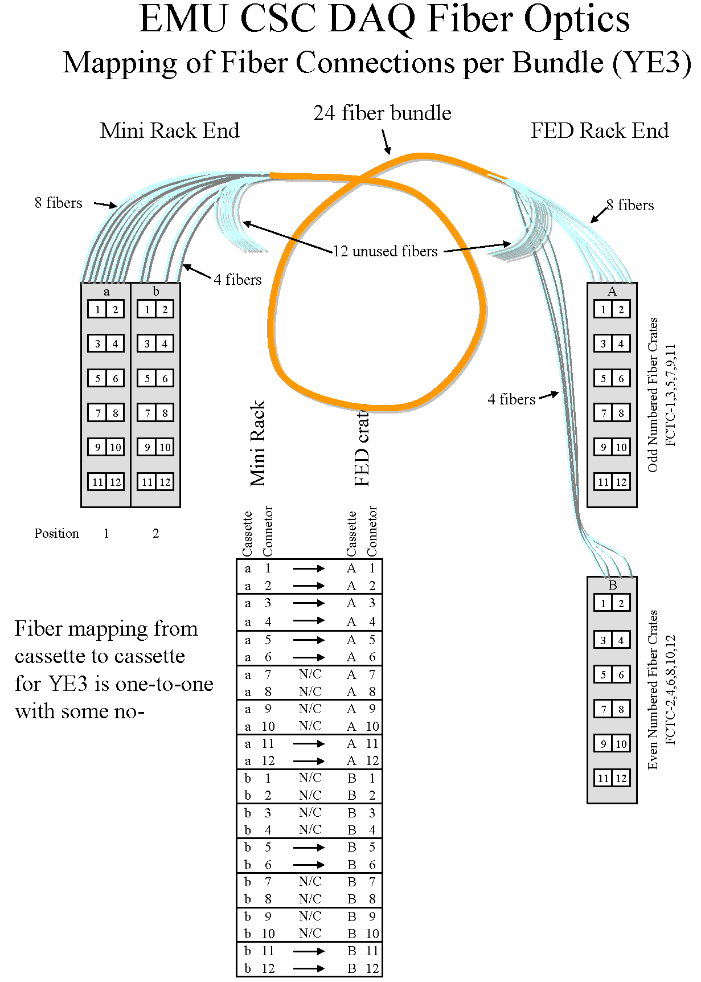

Figure 4
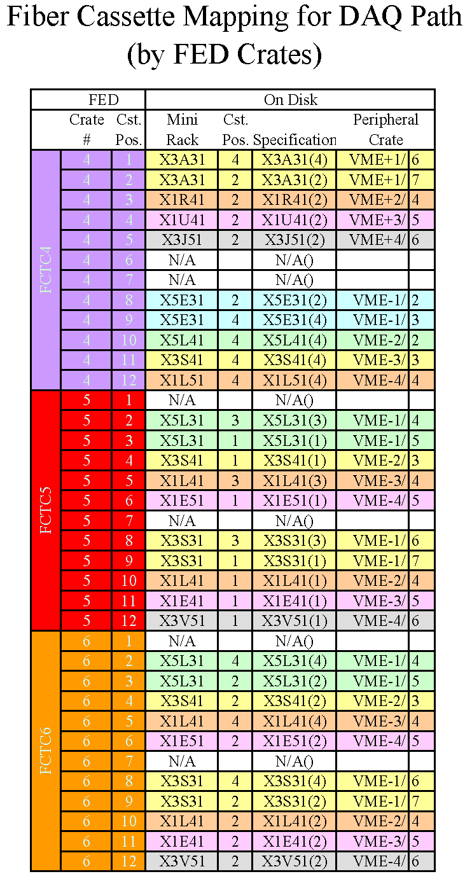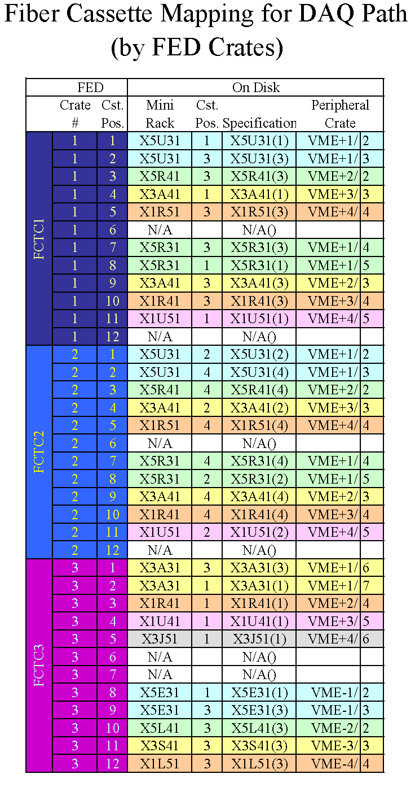

Table 1
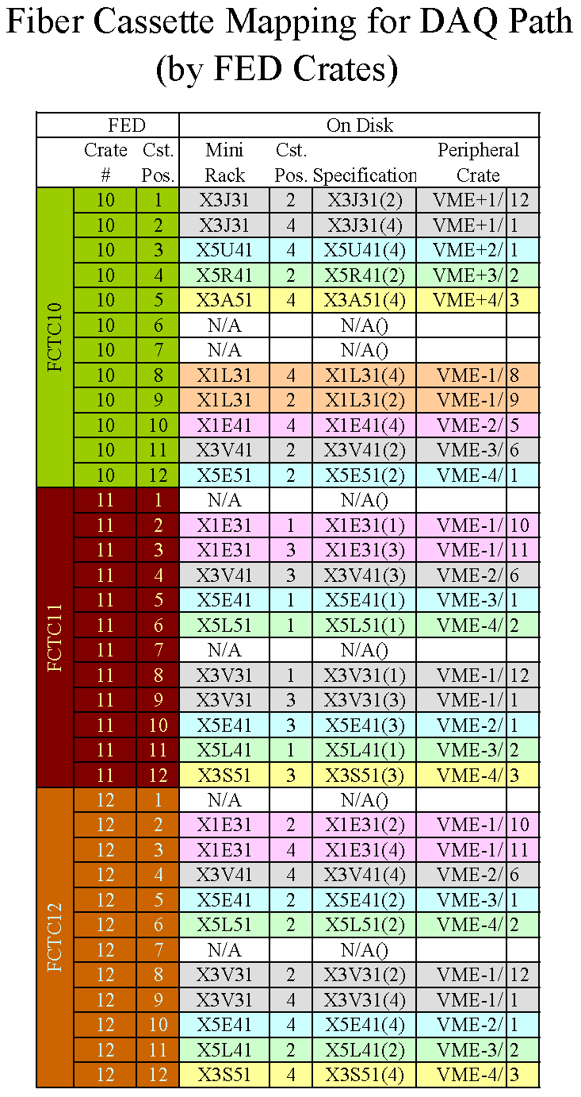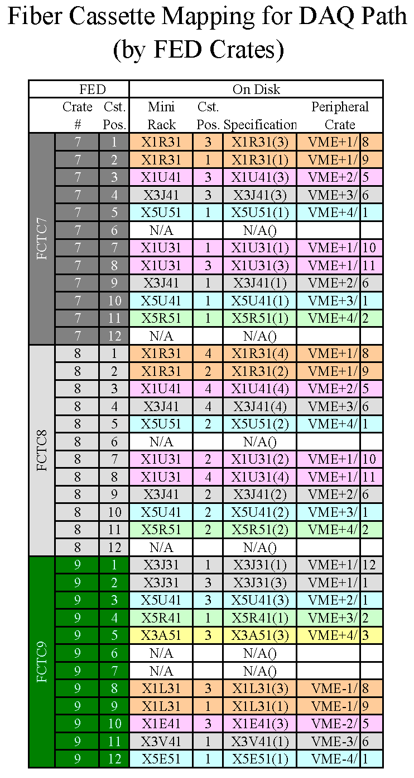

Table 1 (continued)
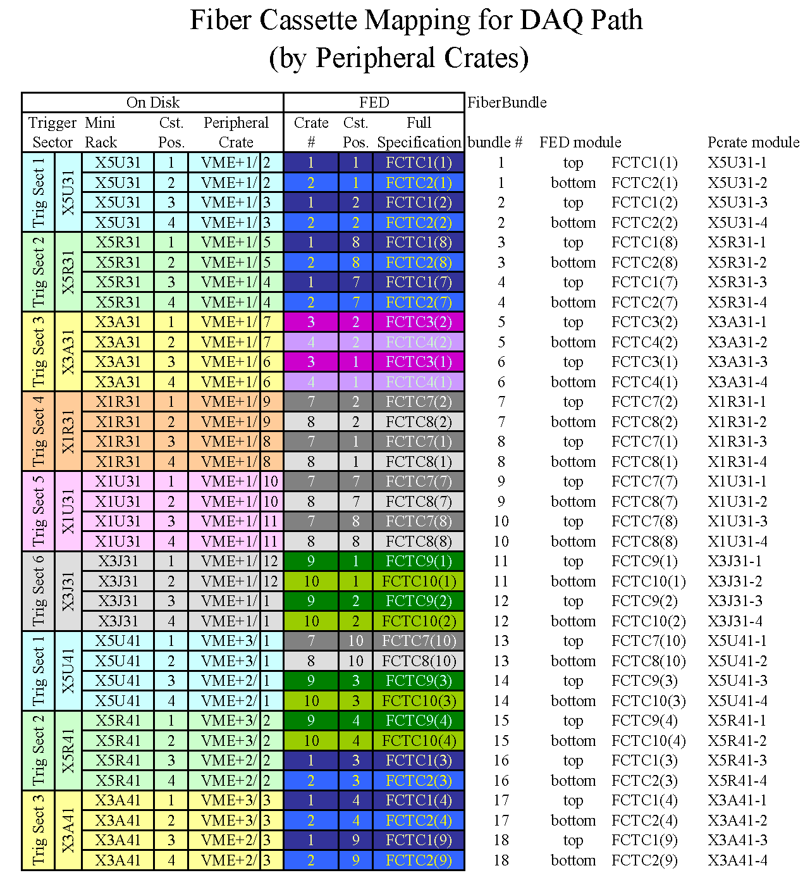

Table 2

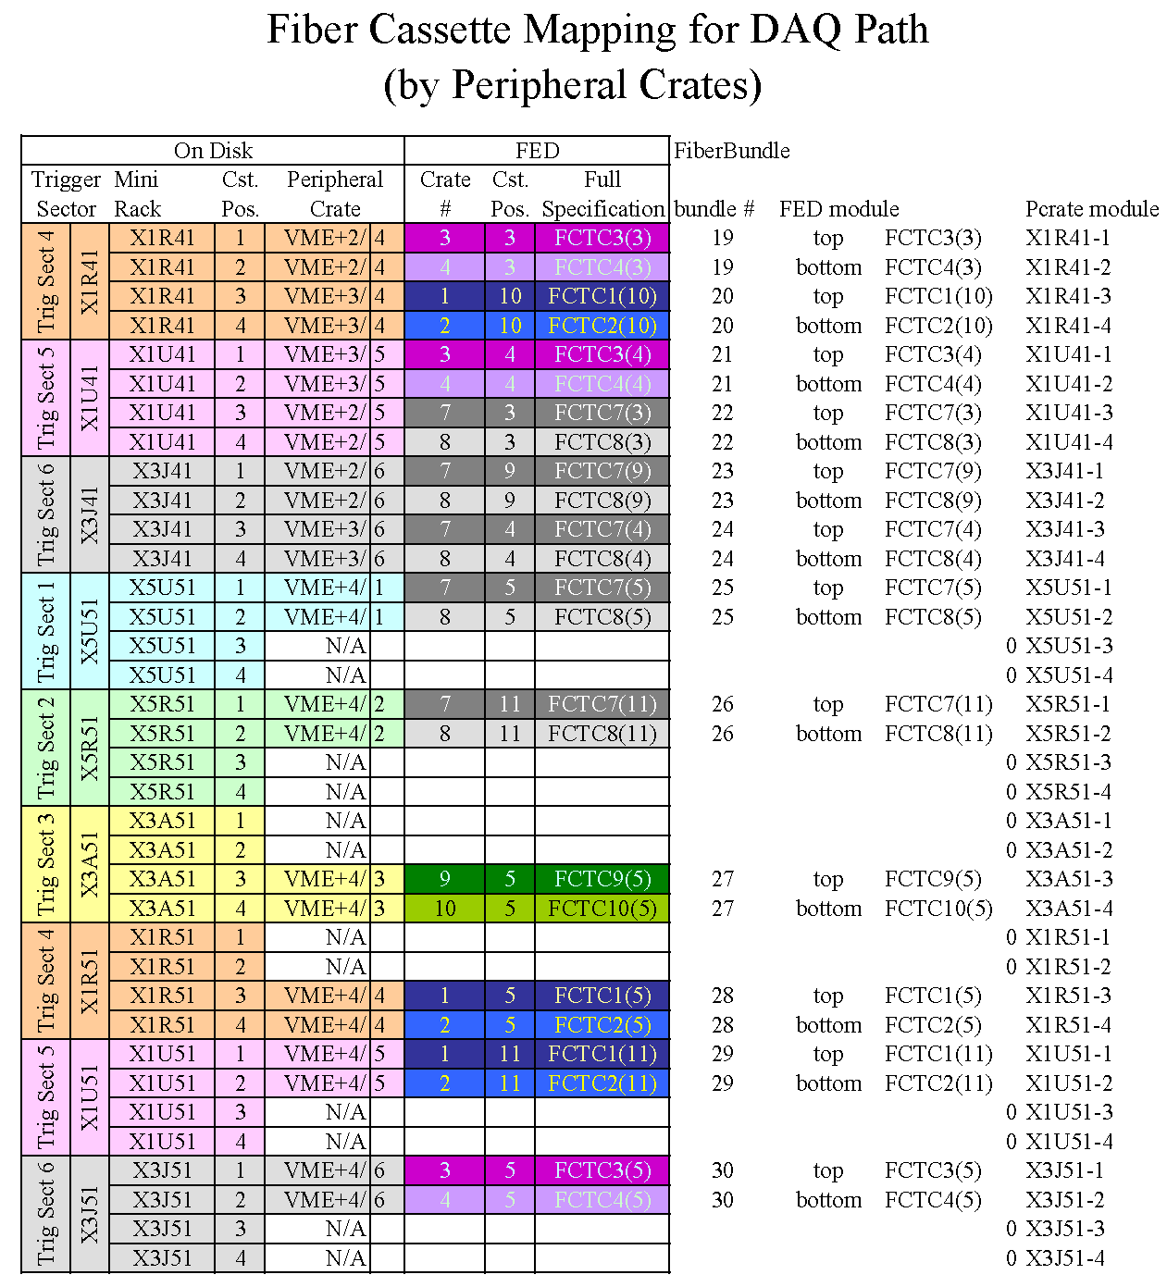

Table 2 (continued)
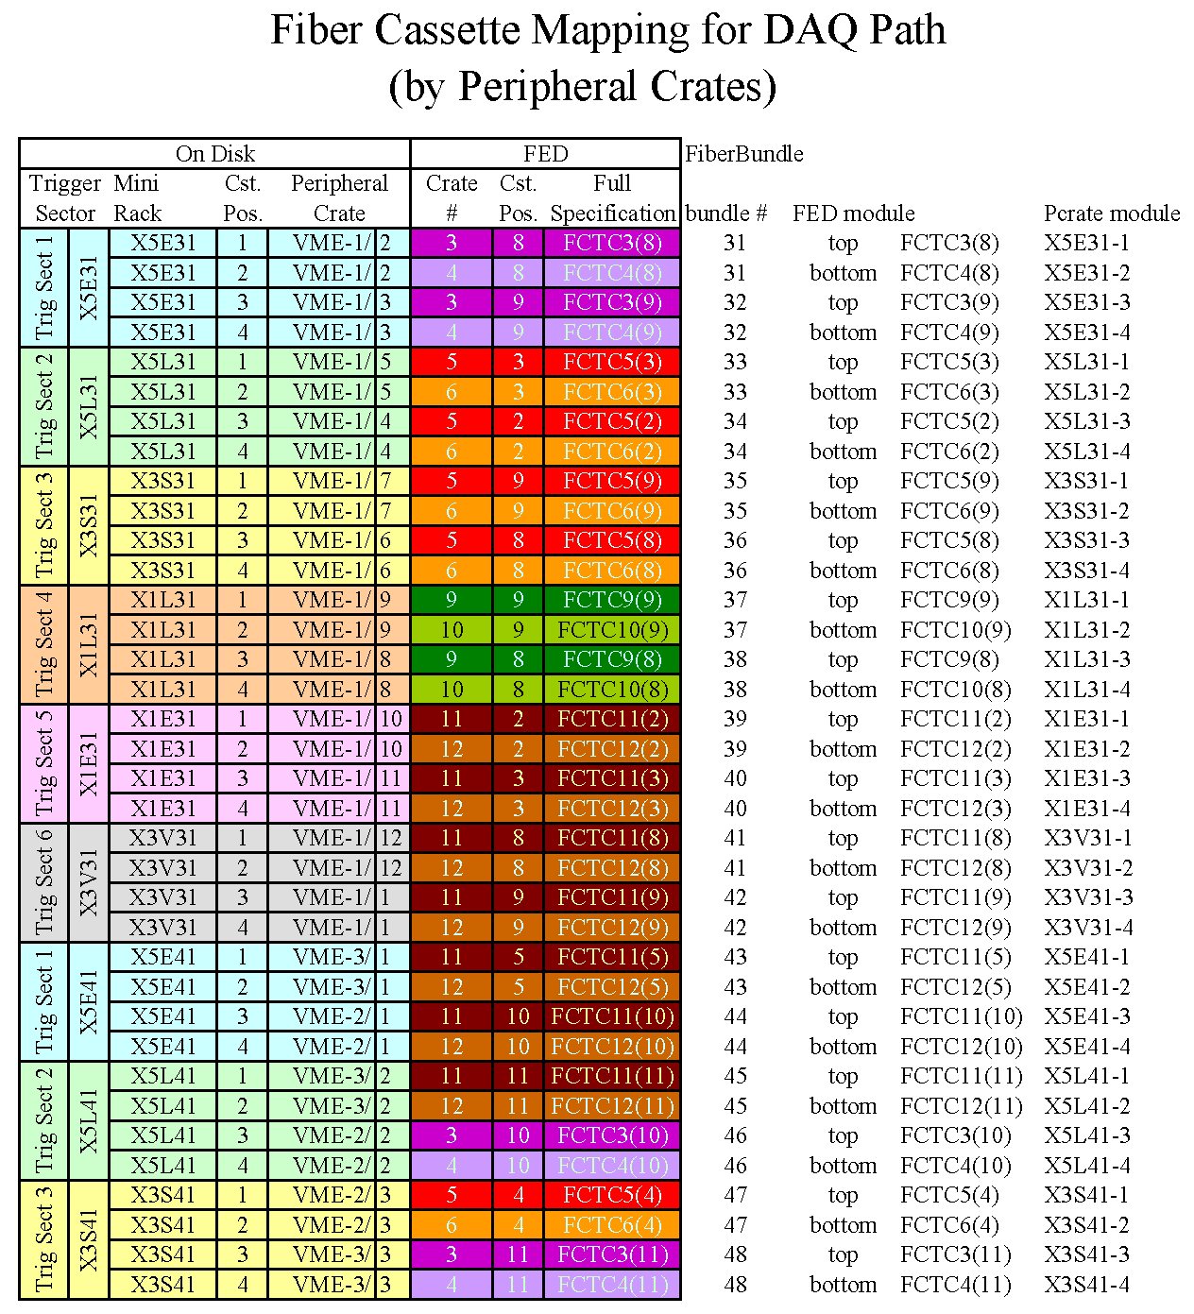

Table 2 (continued)

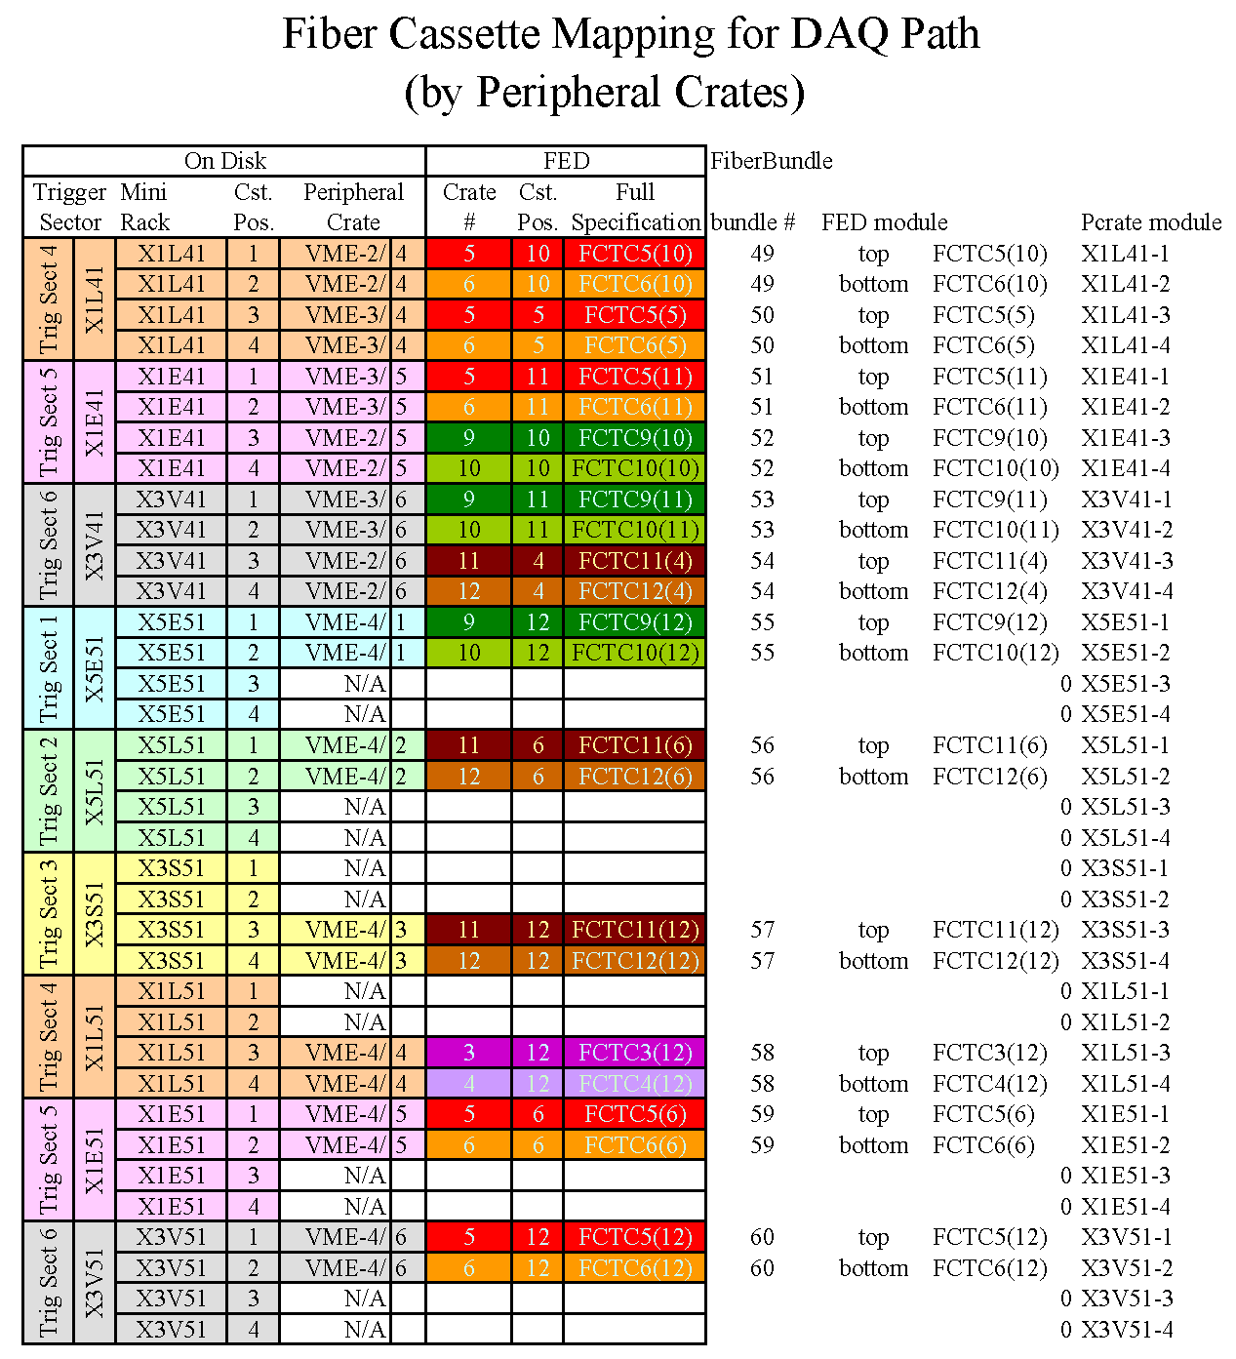

Table 2 (continued)

