THINKING ABOUT MOTION AND FORCE
USING
DIAGRAMS AND GRAPHS

I. Introduction

Today, we extend the previous lab by adding the concept of force—the physical quantity that causes motion to change. Our goals are to:
- reinforce our ability to construct and interpret motion diagrams;
- reinforce our ability to interpret kinematic graphs;
- learn to represent the forces exerted on an object using free-body diagrams; and
- combine these tools to analyze the relationship between motion and force.
As discussed last week, a major objective of science is to discover rules that seem to guide the behavior of our universe and to apply these rules for useful purposes. For the rules to have meaning, the symbols used to discuss them must evoke mental images. We have now introduced two qualitative ways to describe linear motion—motion diagrams and kinematic graphs. Kinematic graphs provide a detailed record of the motion. Motion diagrams contribute to our understanding and intuition about the quantities used to describe motion— time, position, velocity, and acceleration.
It is equally important to develop intuition about the concept of force and to form visual images that help us understand the different types of force. Suppose, for example, that we use the symbol N to represent the normal force that one surface exerts on another—such as the force of a table on a book. It is important that the symbol N triggers in our mind an image of the nature of the contact between the table and the book. It is also important that we are able to represent that force in other ways, for example, using an arrow.
Another goal is to see how these different quantities are related. For example, how does the force that one object exerts on another affect the motion of the other object? Is there a rule relating force and motion? If so, what is that rule? How do we use that rule for useful purposes? Answering these questions are goals of today’s lab and of later labs.
Prelab Assignment: Read and digest Appendix C and complete the activities in Section III. In addition, review the kinematic graph and motion diagram material from last two labs.

II. Color Code for Different Types of Quantities
Fig. 1 Expected force analysis.
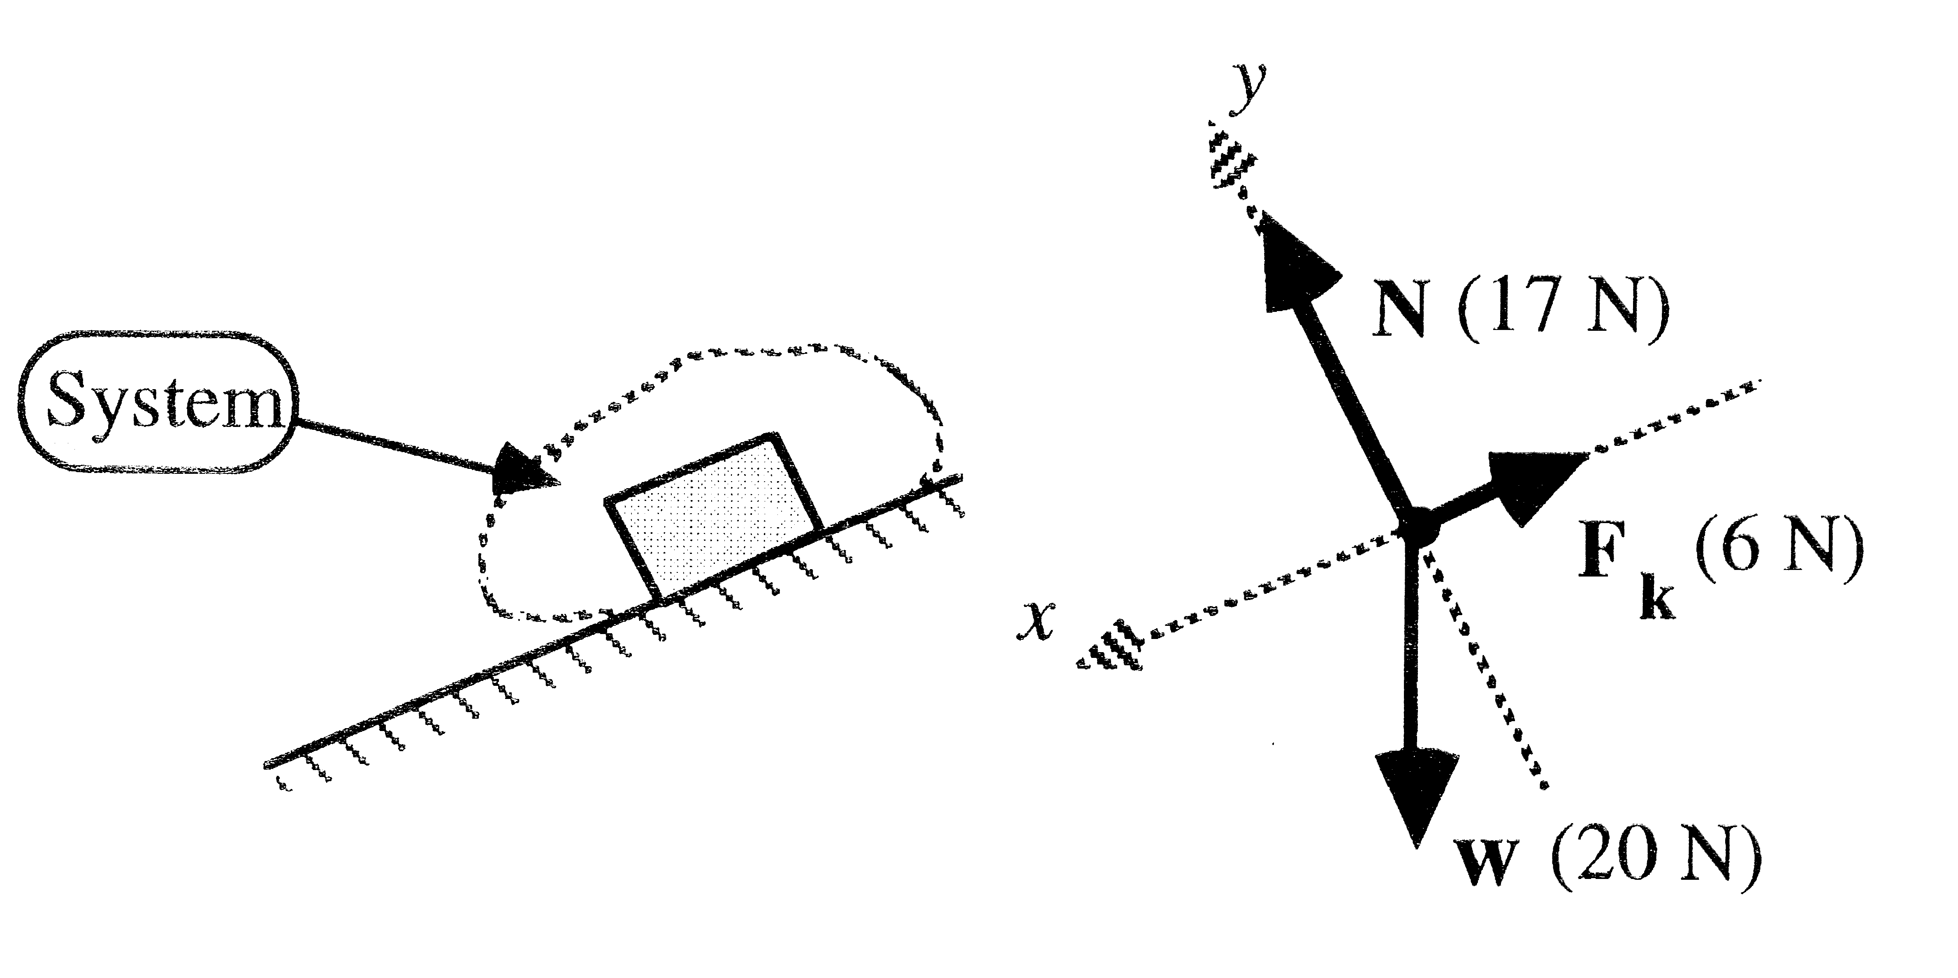

When drawing diagrams to represent different types of physical quantities, use the following color code:
LIGHT BLUE: force F
RED: velocity v
BLUE: acceleration a
BLACK: position x, y or r
Your drawings will be in pencil. In case a mistake is made or you change your mind later, you can erase.
N : Normal force of incline on bottom surface of the block.
F_{k} : Kinetic friction force of incline on bottom surface of the block.
w : Gravitational force of earth’s mass on the mass of the block.

III. Force & Free-Body Diagrams
(complete all activities in this section before lab)
Last week, you concentrated on diagrammatic and graphical methods to describe motion. You were not concerned with the reasons for the motion to change or to not change. This brings us to the subject of the force that one object exerts on another. Appendix C has a brief review of the concept of force as well as a qualitative introduction to various types of force and to the construction of free-body diagrams and force diagrams. Be sure to study this appendix before proceeding.
A series of thought experiments are described in parts A and B of this section. For each experiment, construct a free-body diagram for the system that is identified in the sketch and a table that indicates for each force the object outside the system that exerts the force and the object or part of the object in the system on which the force is exerted. Fig. 1 illustrates what is expected. Part C contains some conceptual questions about force and motion which you should think about carefully while picking your answers.

A note about force: Aristotle in about 300 B.C. viewed force as a robust muscular action. A dumb, passive table or wall could not exert a force. His views about force, physics, and science in general were based on everyday experiences and careful thought about those experiences. Many of us enter introductory physics courses with similar experiences, and often with similar beliefs. It is nice that we develop with little effort beliefs that are similar to those of the great Aristotle.
Now for the bad news. Many of Aristotle’s beliefs differ from the modern ideas of physics. Walls, floors, and tables are actually pretty smart—they exert nice compliant forces. Physicists find that common-sense beliefs (like Aristotle’s) that contradict presently accepted science are VERY difficult to change. One strategy to help reground Aristotlian thinking is to use so-called anchoring experiments. In these anchoring experiments, we find a situation that is believable—and that also resembles the situation that does not make sense. We then move from the believable anchoring experiment in small steps to the more abstract idea. The questions below are an example of this.
A Normal force, tension, and weight

A block which weighs 20 N hangs from a spring scale, as shown below. The block rests on a platform scale so that the platform scale reads 12 N. The spring scale attached to the string holding the block reads 8 N. Construct a free-body diagram for the system that is circled in the sketch below. For all force arrows shown in the diagram, be sure to indicate in a separate table the object outside the system causing the force and the object or part of the object in the system on which the force is exerted. If you know the magnitude of any of the forces, indicate their values in parentheses. [Is gravity an “object”?]
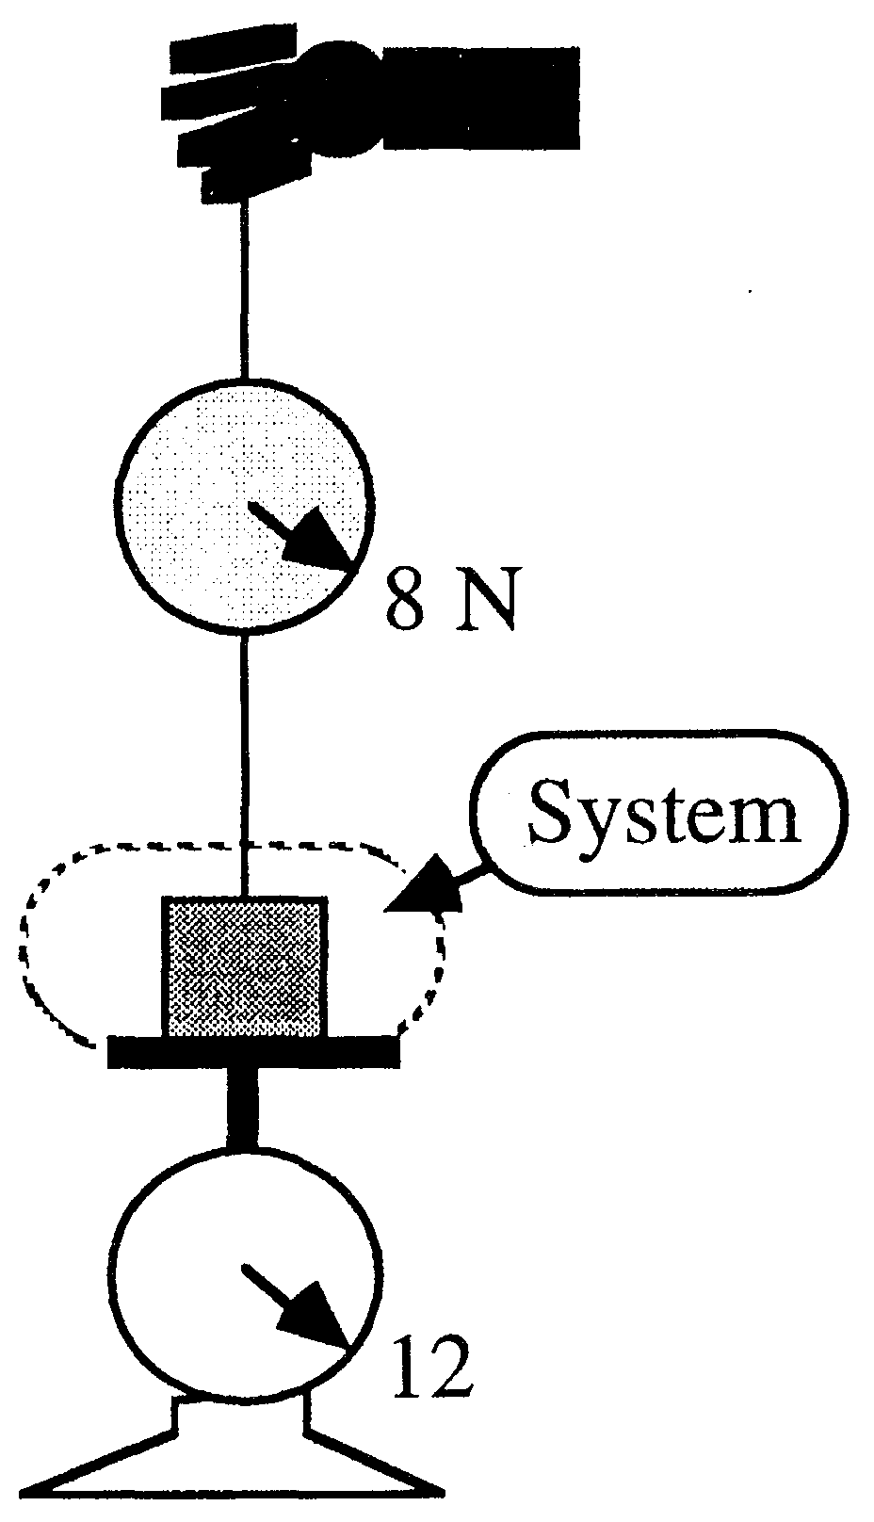

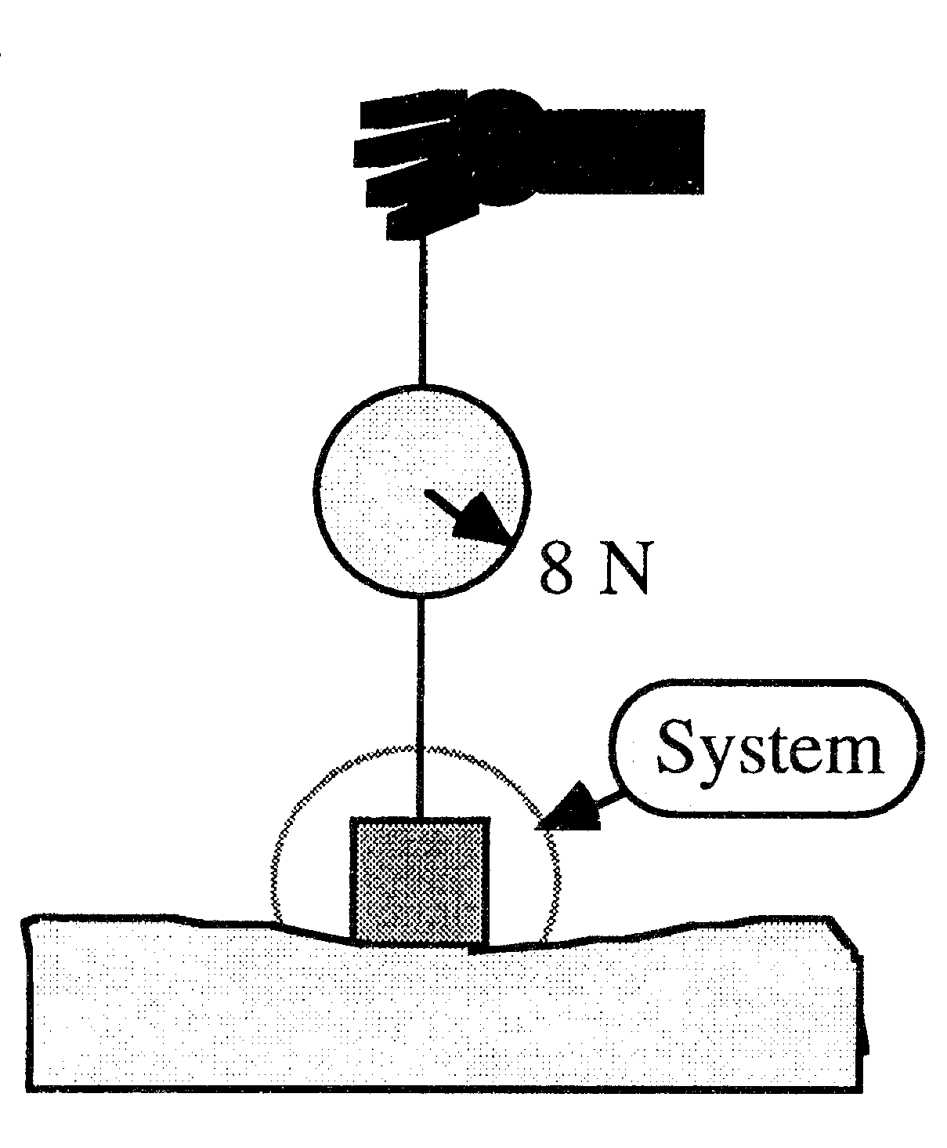
Now, the same block rests on a piece of foam rubber. The block sinks slightly into the foam. The spring scale has the same reading as before (8 N). Is the system’s free-body diagram different than before? If so, how does it differ?

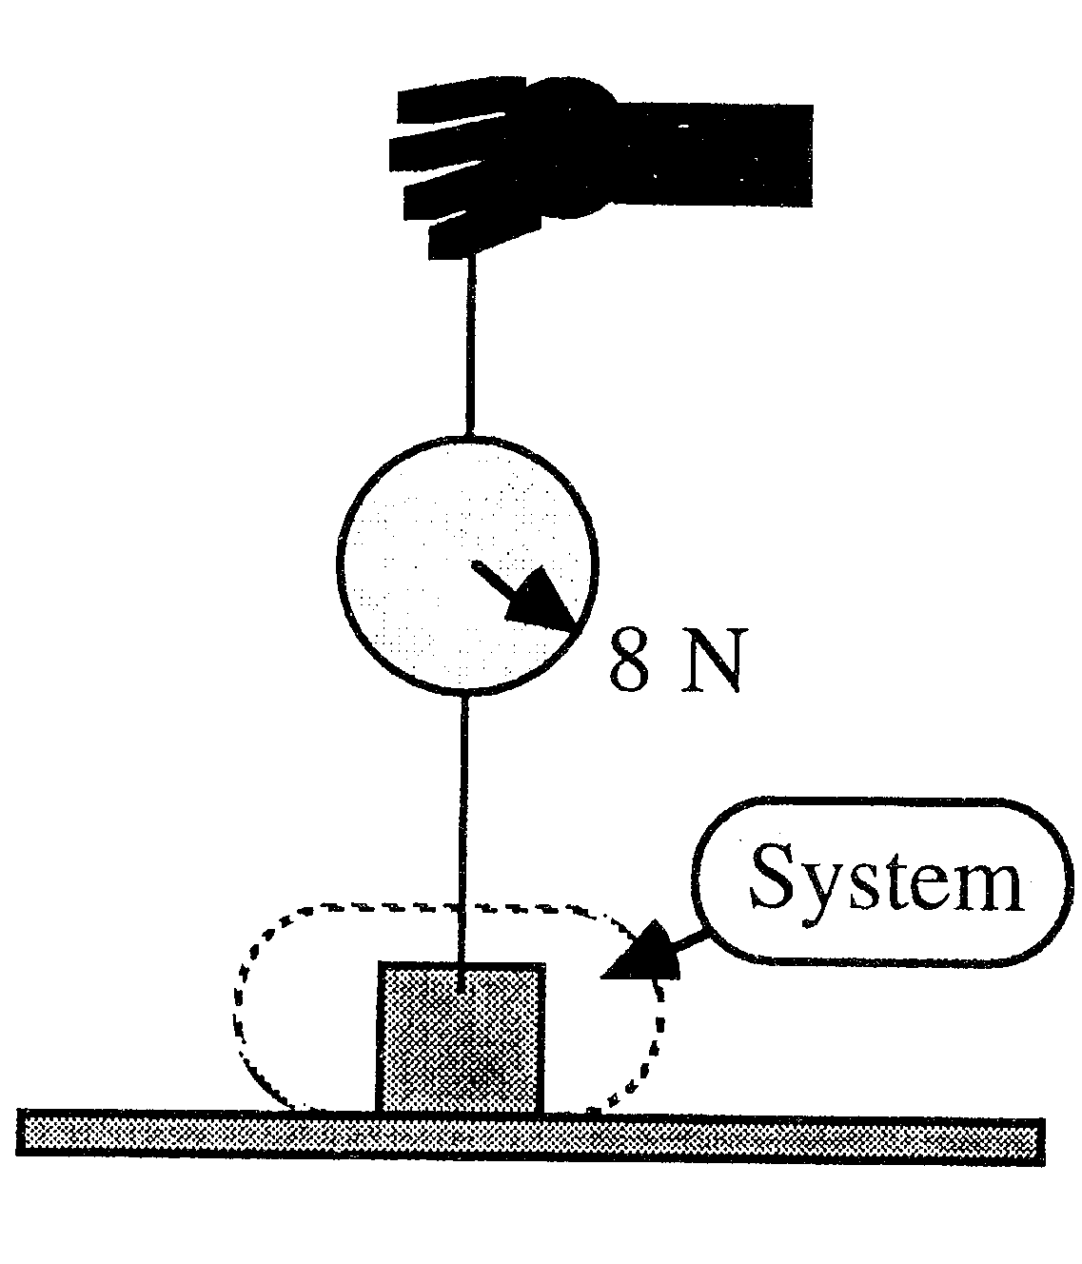
Finally, this time the block rests on a table so that the spring scale has the same reading as before (8 N). Is the free-body diagram different than before? If so, how does it differ?

How is the block resting on the surface of the table similar to the other cases, or to you resting on the mattress of a bed? How would you represent the force of the bed on you? How would that force differ if your weight magically doubled?
Beds are fairly smart—they can with little effort figure out how much strength to use in holding up a person laying on the bed, thus preventing the person from falling to the floor or from being launched toward the ceiling. Inclined surfaces are even smarter. They adjust their push to allow a coasting car to roll down a hill without sinking in too far and without being launched into the air. The normal force is a compliant force that adjusts to a variety of needs. Tension forces are also compliant and change as the tugs on their ends vary.

B. Static and Kinetic Friction

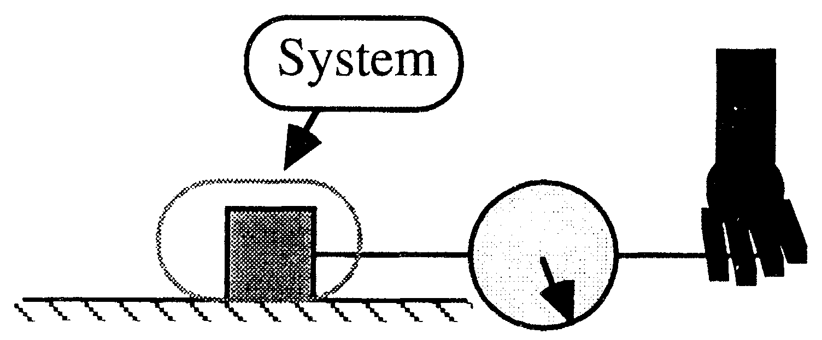
Consider another thought experiment. A string pulls horizontally on our block that weighs 20 N. The block now rests on a horizontal surface. The other end of the string is connected to a spring scale that measures the tension in the string. A person pulls gently at first and increases the string tension slowly. When the tension reaches a certain value, the block starts to slide.
The block is shown below while being pulled by various string tension forces. In (a)-(c), the block has not yet started to slide. The tension in (c) is the most that can be exerted on the block before it starts to slide on this particular surface. In (d), the block is sliding at increasing speed toward the right. For each situation, draw a side-view free-body diagram for a system that includes the block and a short section of string attached to the block.
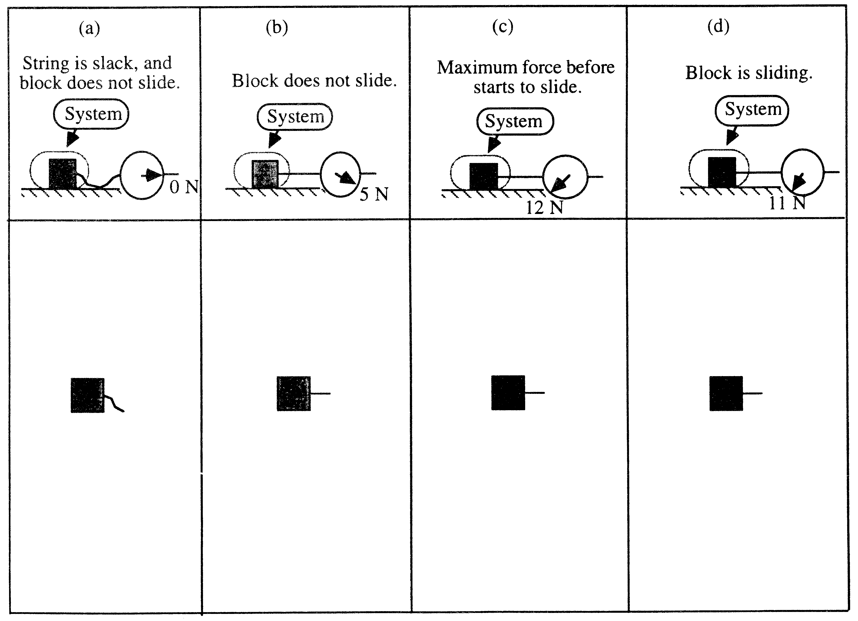
C. Forces and Motion
A
B
C
- A clown is tossing three shiny balls labeled A, B, and C. “A” just left the clown’s hand and is moving upward. “B” is at its highest point. “C” is going down toward the clown’s hand. Draw on the picture to indicate the forces on each of the balls.

- A woman exerts a constant horizontal force on a large box. As a result, the box moves across a level (horizontal) floor at a constant speed “vo”. The constant horizontal force applied by the woman...
  - has the same magnitude as the weight of the box.
  - is greater than the weight of the box.
  - has the same magnitude as the total force which resists the motion of the box.
  - is greater than the total force which resists the motion of the box.
  - is greater than either the weight of the box or the total force which resists its motion.

- If the woman in the previous question doubles the constant horizontal force that she exerts on the box to push it on the same horizontal floor, the box then moves...
  - with a constant speed that is double the speed “vo” from the previous question.
  - with a constant speed greater than “vo”, but not necessarily twice as great.
  - for a while with a speed that is constant and greater than “vo”, then with increasing speed.
  - for a while with an increasing speed, then with a constant speed thereafter.
  - with a continuously increasing speed.

- If the woman suddenly stops applying a horizontal force to the block, then the block will...
  - immediately come to a stop.
  - continue moving at a constant speed for a while and then slow to a stop.
  - immediately start slowing to a stop.
  - continue at a constant speed.
  - increase its speed for a while and then start slowing to a stop.

- An object’s velocity as a function of time is shown in the graph on the right. Which of the following graphs best represents the net force felt by the object in the same period of time?

(A) (B) (C) (D)
F
t
F
t
F
t
F
t

IV. How are Force and Motion Related?

You have now learned two methods to represent motion—motion diagrams and kinematic graphs. You have also learned to represent the forces exerted on an object using free-body diagrams. Is there some relationship between force and motion? If so, what is that relationship? Does this relation depend on the coordinate system we use to analyze a problem? We will try to answer that question by analyzing an experiment involving the motion of a cart.
The motion is slightly complicated by the fact that the nature of the cart’s motion changes part way through the experiment. Initially, a string pulls the cart so it moves faster and faster. Then, the string stops pulling and the cart’s speed decreases because of friction. Thus, each motion problem is really two problems: one with the cart’s speed increasing and the other with it decreasing. The end of one type motion is the beginning of the next type. This is a common way to break more complex problems in parts. The separation between the parts occurs when some force, like the force of the string on the cart, starts or stops acting on the cart. Worksheets on the next two pages are used to analyze the experiment.

Experiment 1:
The cart starts at rest about O.5 m from the motion detector. A string attached to the cart passes over a pulley and to a metal block that hangs at the end (it is initially supported by the hand). When the hanging block is released, the cart begins to move away from the motion detector. After traveling about 1 m, the block reaches the floor or a small bench and stops falling. The string also stops pulling the cart. Because of friction, the cart now slows to a stop. The analysis of the two parts of this experiment occurs on the next two pages. Make individual predictions first. Then check with your lab group to make even better group predictions. Then, try the experiment to see how you did.
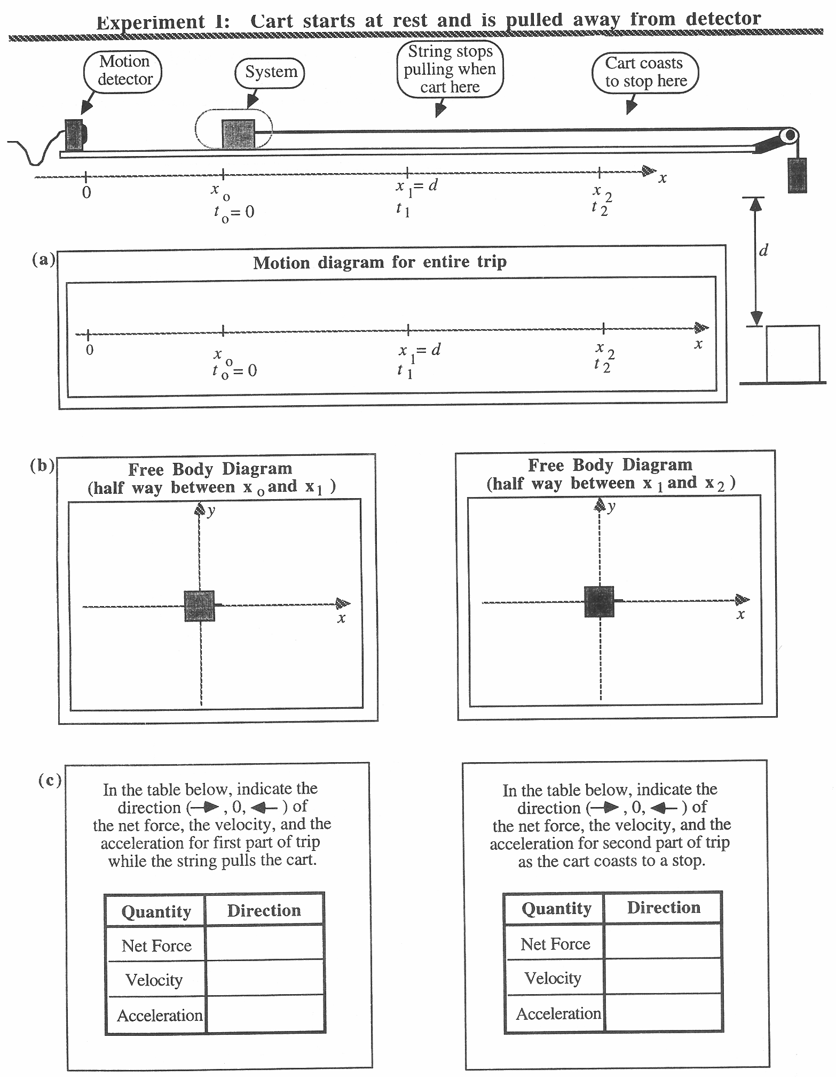
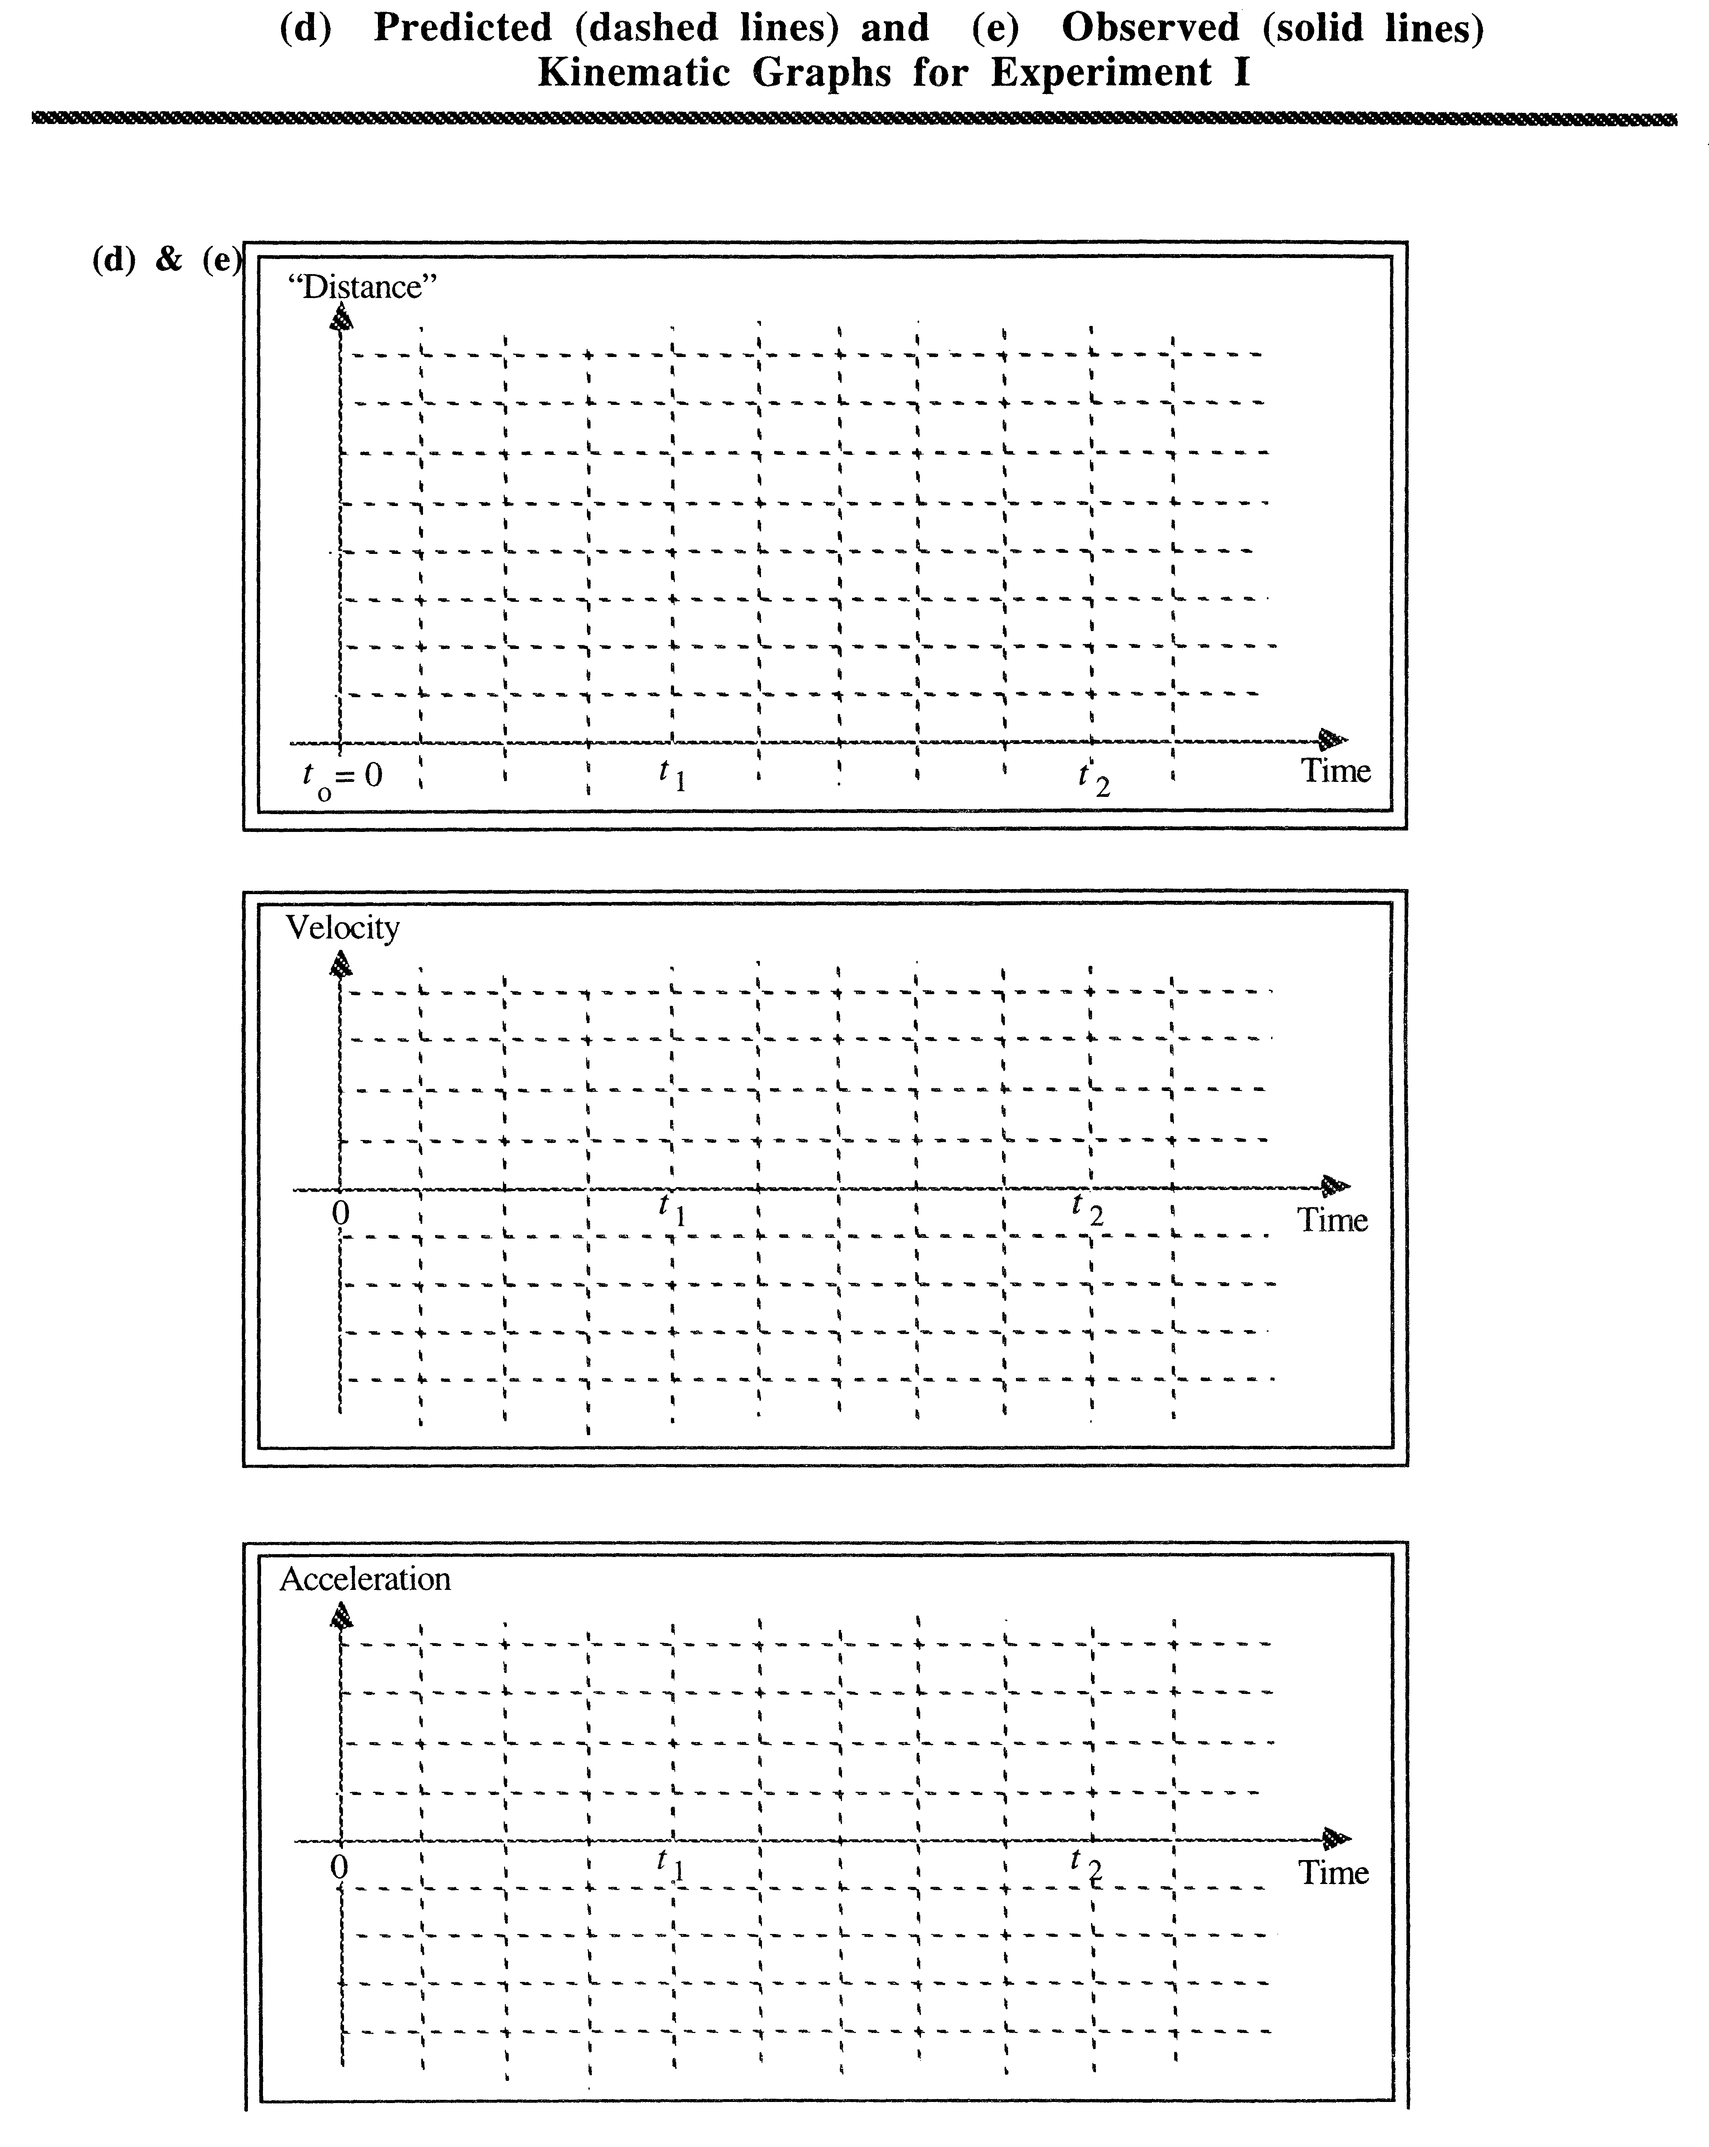
Based on this experiment, how does net force seem to be related to motion? Be precise.

Answer this question and provide evidence for your answer based on the previous experiment. Before moving on, have your lab instructor review your conclusion.

Experiment 2:

On your computer is a Virtual Reality demonstration of a block you can push. Using the joystick, apply the necessary forces on the block to recreate the kinematic graphs from the previous experiment. Describe the forces in words and by sketching a graph of the force as a function of time.

Experiment 3:

Using the Virtual Reality software, do the following:

Mission 1: Reaching and maintaining a constant speed.

In this mission, you will start with the block at rest. Then, by applying forces to it with the joystick, try to get its speed to increase to 2 m/s and then stay at a constant value of 2 m/s afterwards.

- First, predict how you would need to apply force to accomplish this mission. In particular, think about how the force might change with time, and how the presence or absence of friction might alter your answer.

- Draw three free body diagrams for your object: First, when it is at rest. Second, when it is getting up to speed. Third, when it is “cruising” at a constant speed.

- Set the frictional coefficient to 0.5 and try to accomplish the mission. Once you have succeeded, write down how you did it.

- Describe how you think the force will have to change if the frictional coefficient is set to 0.3 or 0.1. Then, try both new values for the coefficient and describe what you discover.

- Set the frictional coefficient to 0 (this represents frictionless motion). Predict how you would apply the force in this situation. Try this as well and describe the result. Compare to the situations in which there is friction.

Mission 2: Applying and maintaining a constant force.

This time the goal is to apply a force which is constant in strength and direction. You will be asked to make observations about the motion of an object when it feels this constant force.

- Set the frictional coefficient to be 0, and the initial speed to 0. Apply a small, constant force (3-4 Newtons) and write down what you observe.

- Stop the block, set the frictional coefficient to 0.1, and apply the same small force as before. Compare the block’s motion with the motion from part a. Does it reach the same velocity? What is different?

- Set the frictional coefficient to 1.0 and apply the same small force as before. Compare the block’s motion with part a and part c.

- Bring the block to rest a few meters away from one end of the course and change the frictional coefficient back to 0.1. Apply a small force toward the end of the course and keep applying it, even when the block bounces back against it. Do this several times to make careful observations. Describe and explain what is happening. Does this sort of motion remind you of anything? (Try looking at it from different angles...)

Mission 3: Graphs which depict motion.

- Here is a graph showing the amount of force applied to an object over a period of time. There is no friction. Try to sketch what a graph of the object’s velocity might look like, and explain your reasoning.

F
t
v
t

- Restart the simulation with the block at rest and the friction set to zero. Apply force to the block as in the graph given above and sketch the velocity graph that results. How does it compare to your prediction? If there are differences, try to explain why they are there.

F
F

- Here is a graph showing the velocity of an object over a period of time. Try to sketch what a graph of the force applied to it might look like, and explain your reasoning. (Still no friction.)

v
t
F
t

- Using the simulation, try to reproduce the velocity graph given above. When you have done so, explain how you applied the force in words and with a graph.
A
A

VI. Applying Newton’s Second Law Qualitatively -- ActivPhysics Questions

You have hopefully reached the conclusion that the acceleration of an object is proportional to the net force exerted on that object. In symbols,

∑ F α a.

where the symbol sigma (∑) means “summation,” or in this case the addition of all the forces exerted on the object. The symbol alpha (α) means “is proportional to.” This is Newton’s second law. Use the law to answer the first four questions in ActivPhysics 2.1. Remember to use the following procedure:
- make an individual prediction;
- discuss the predictions with your lab partners and make a group prediction;
- run a new version of the simulation to check your result; and
- reconcile any difference between your predictions and your observations.
- only then, move on to try the next problem.
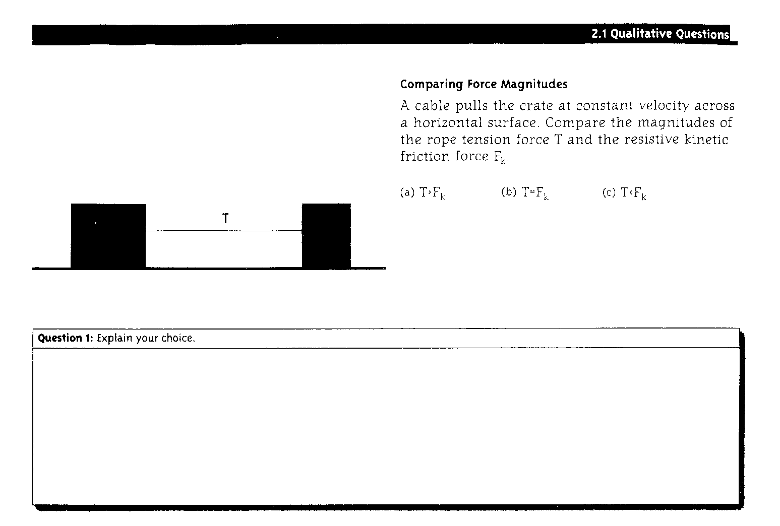

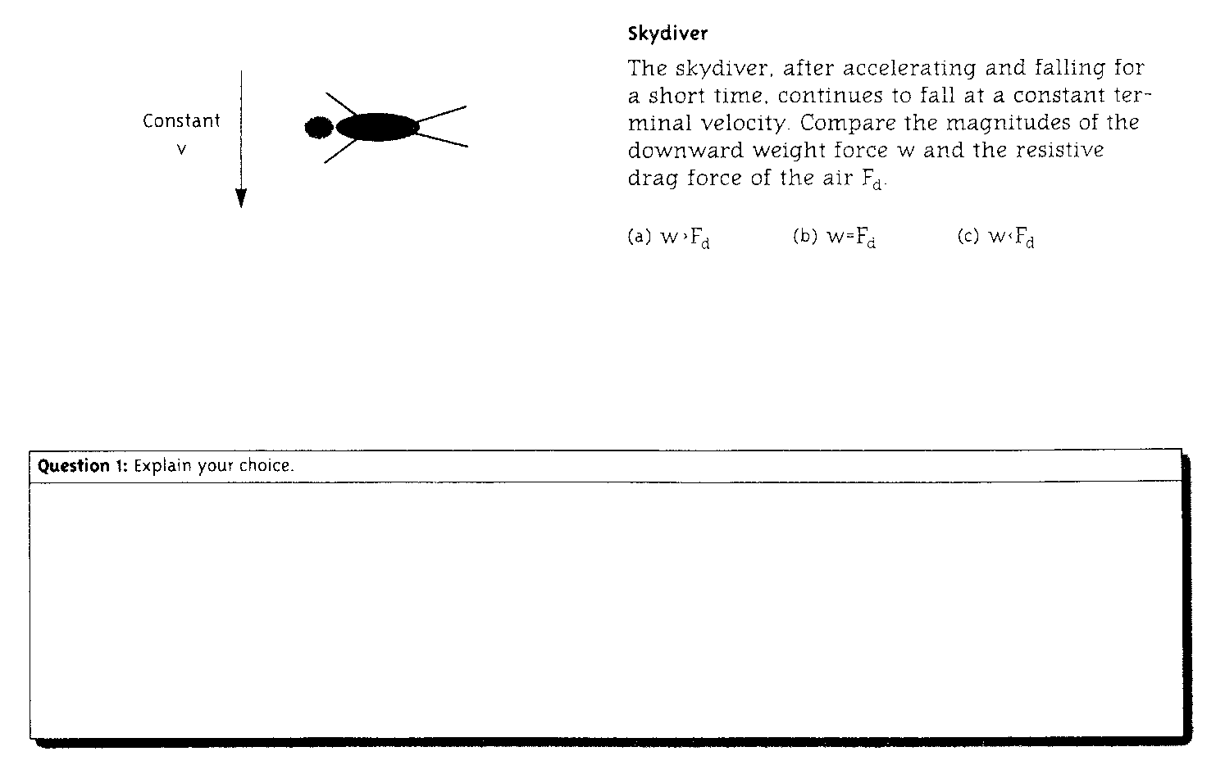

©1997 Addison Wesley Interactive & Alan Van Heuvelen

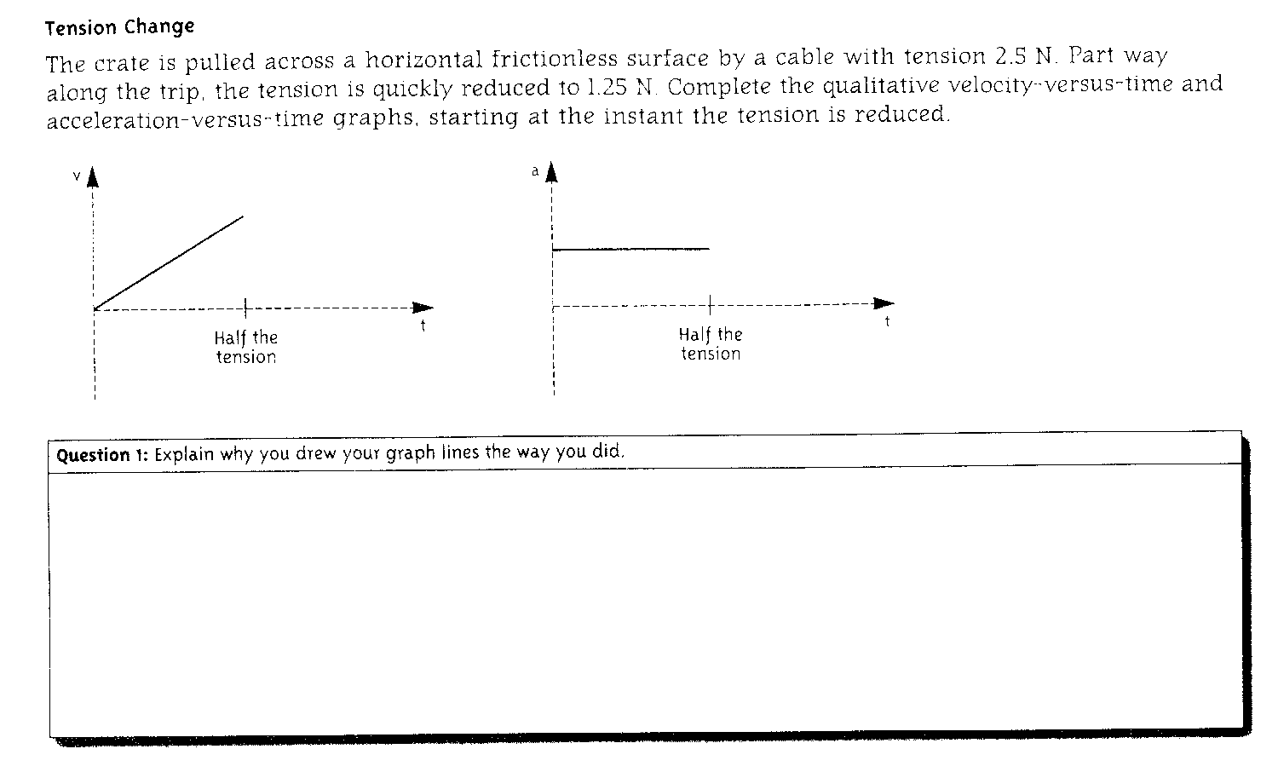

Check with the instructor: ________________

VII. Summary

You have helped to invent Newton’s second law, one of the foundations of classical Physics. You have used the law to analyze several simulation experiments that confront common sense ideas about force and motion that are ubiquitous among the population in general. Next week, we use Newton’s second law quantitatively.

©1997 Addison Wesley Interactive & Alan Van Heuvelen

